PUM0KD00_DVNTD_sfCPConnectionfactory.props.ear_PUM0K_AgreementHistoryAuthCP.png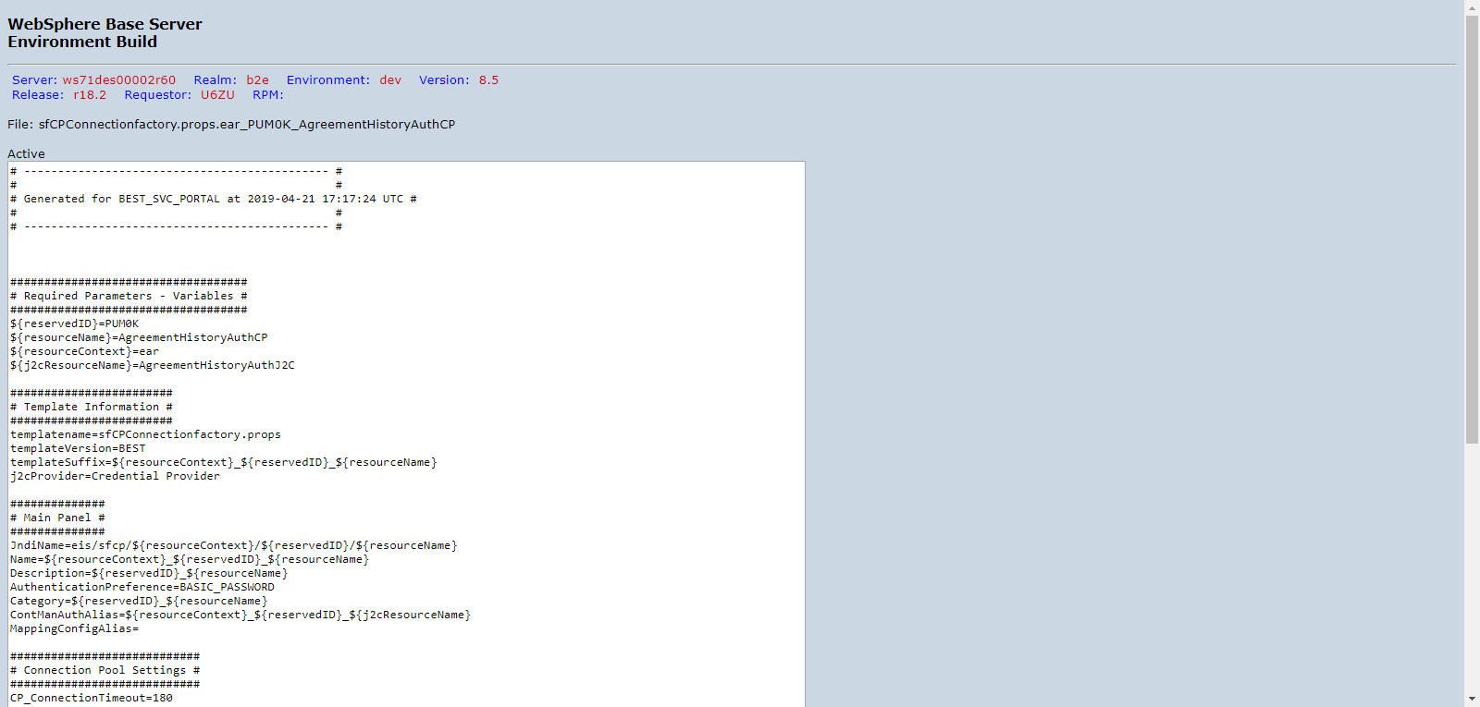

PUM0KD00_DVNTD_sfCPConnectionfactory.props.ear_PUM0K_MailProviderAuthCP.png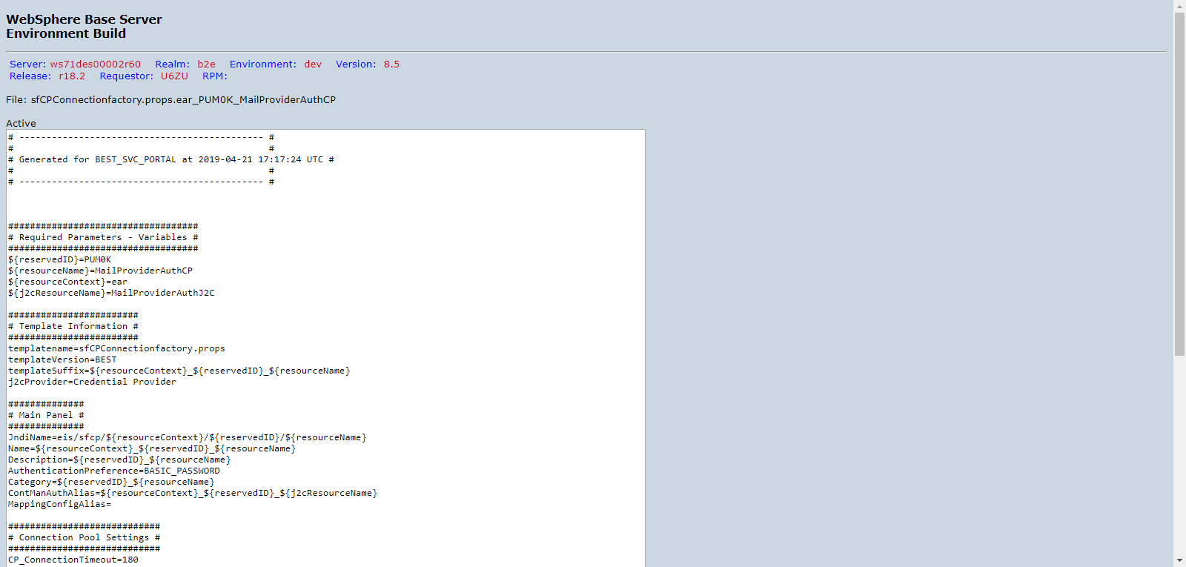

PUM0KD00_DVNTD_sfDB2jccdatasource.props.ear_PUM0K_MetaData.png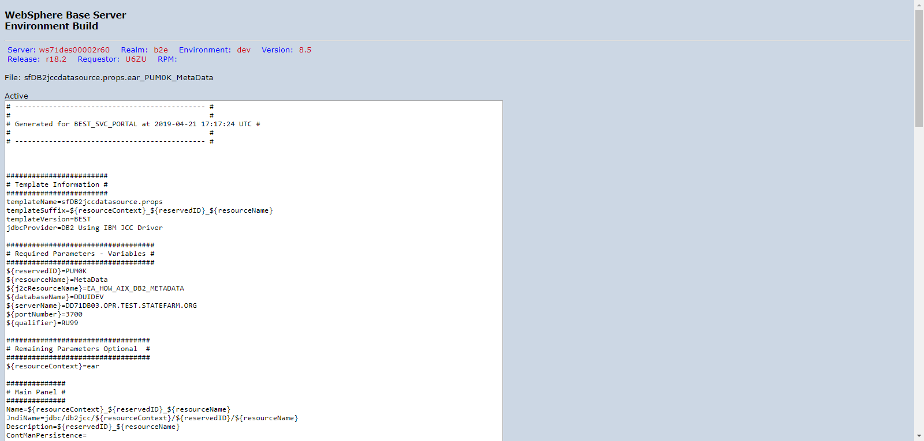

PUM0KD00_DVNTD_sfDB2jccdatasource.props.ear_PUM0K_OFFICE00.png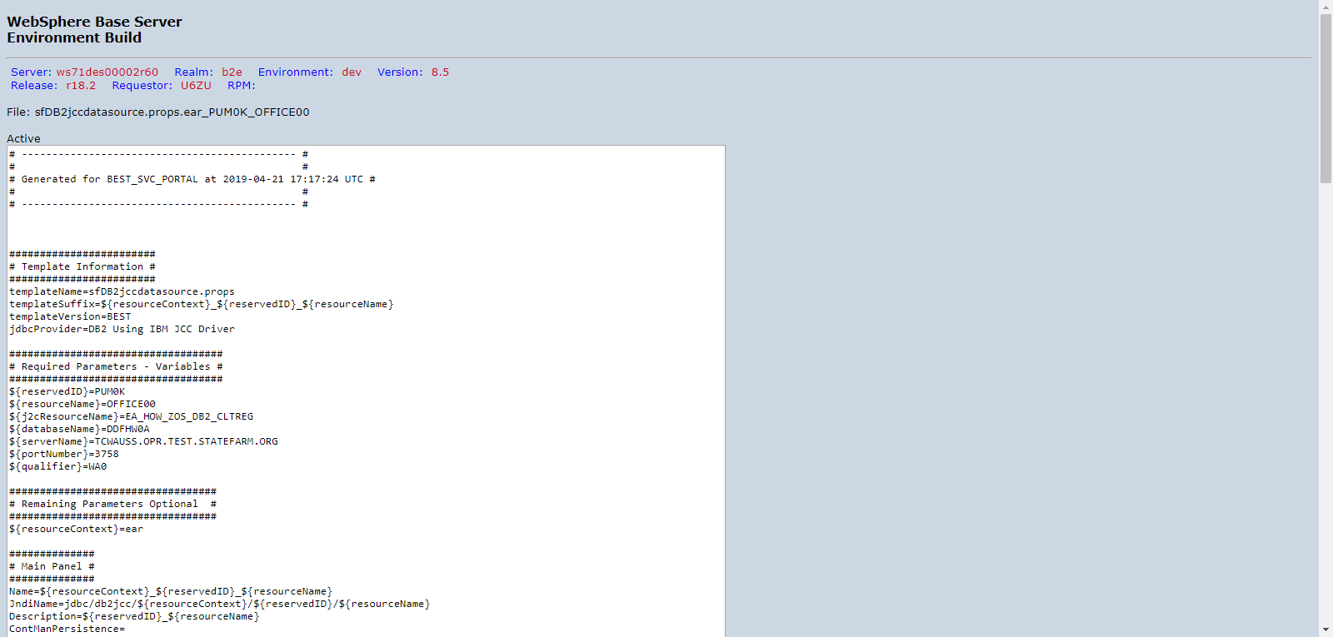

PUM0KD00_DVNTD_sfDB2jccdatasource.props.ear_PUM0K_OFFICE01.png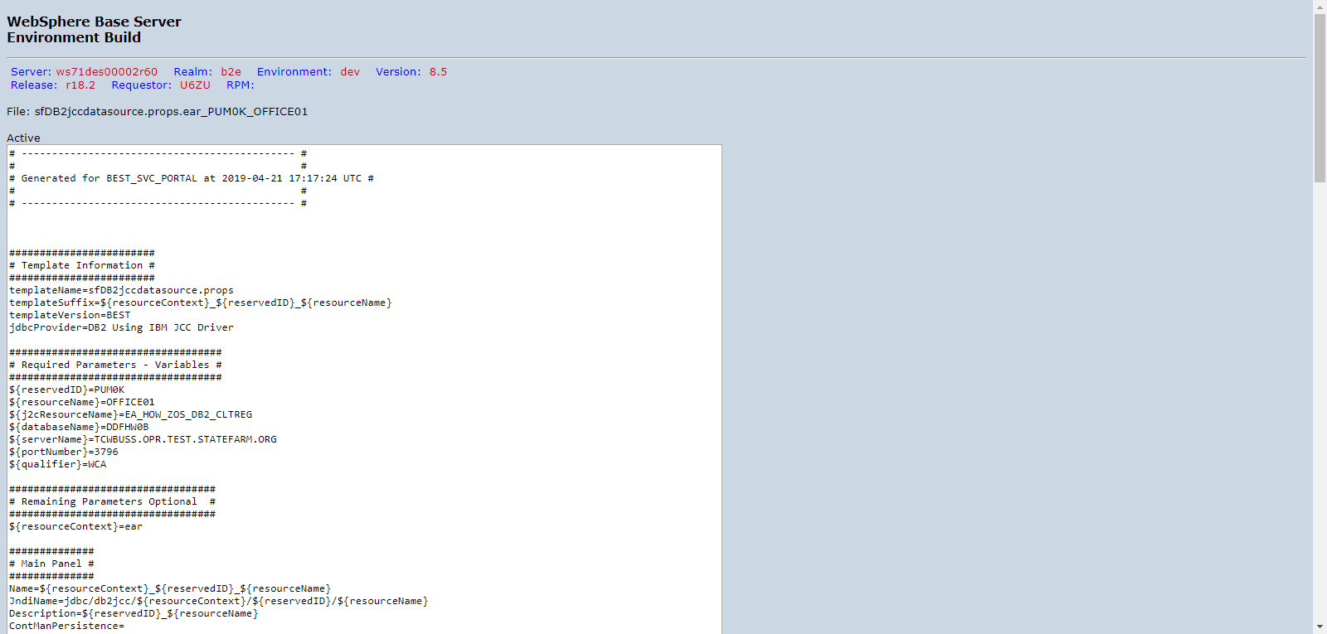

PUM0KD00_DVNTD_sfDB2jccdatasource.props.ear_PUM0K_OFFICE02.png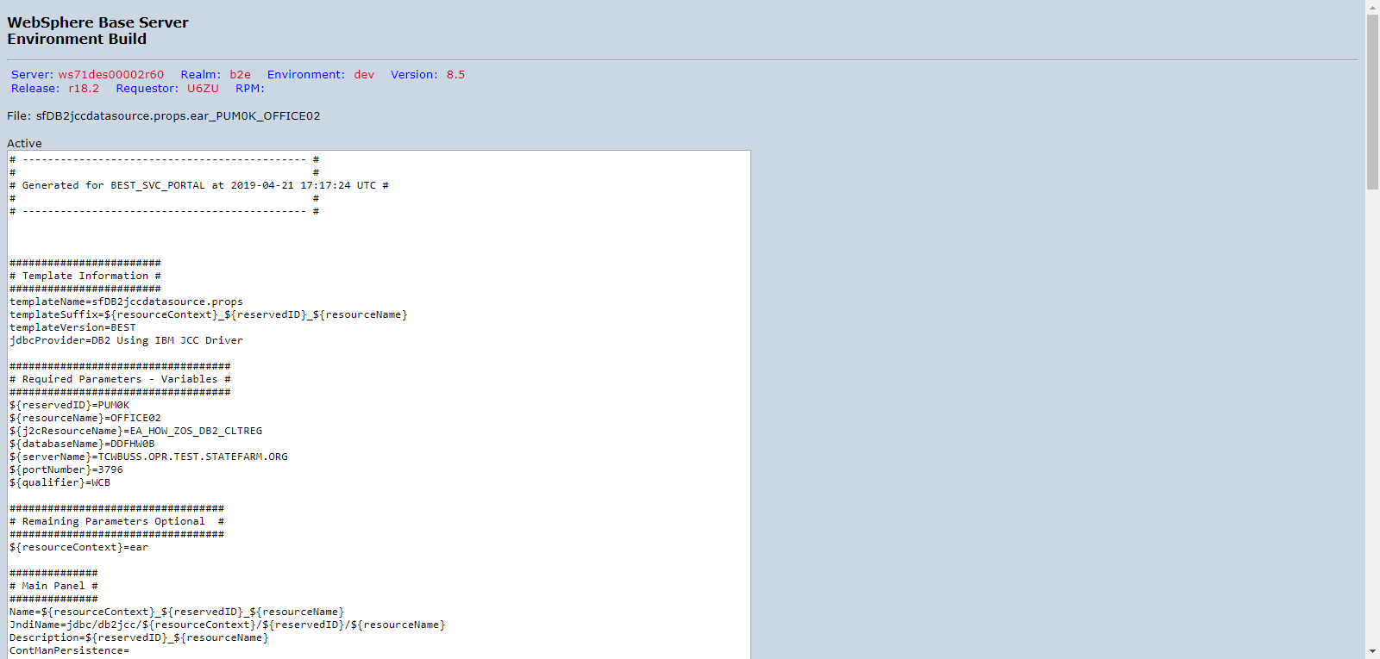

PUM0KD00_DVNTD_sfDB2jccdatasource.props.ear_PUM0K_OFFICE03.png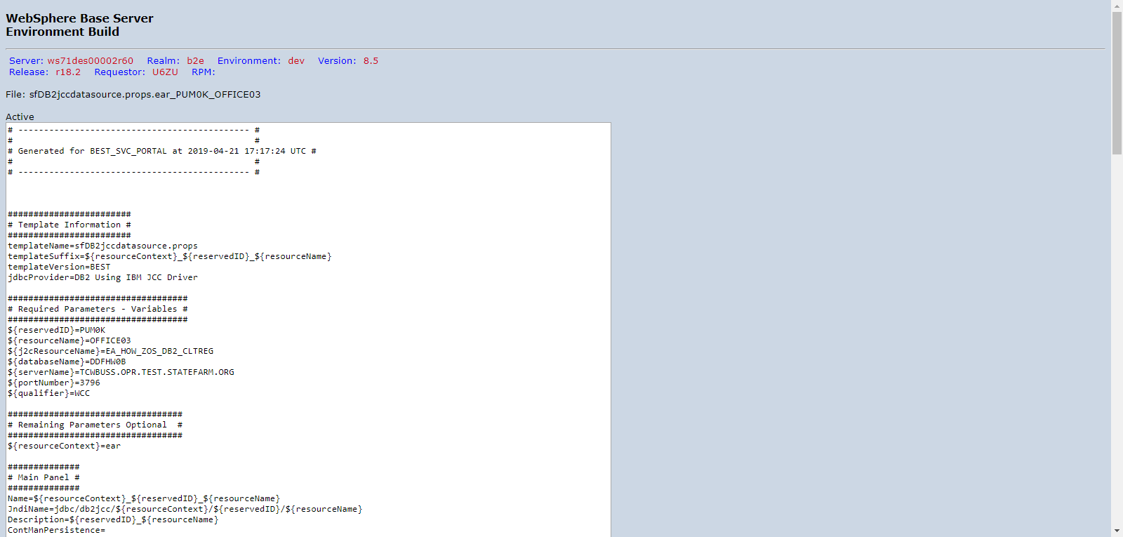

PUM0KD00_DVNTD_sfDB2jccdatasource.props.ear_PUM0K_OFFICE04.png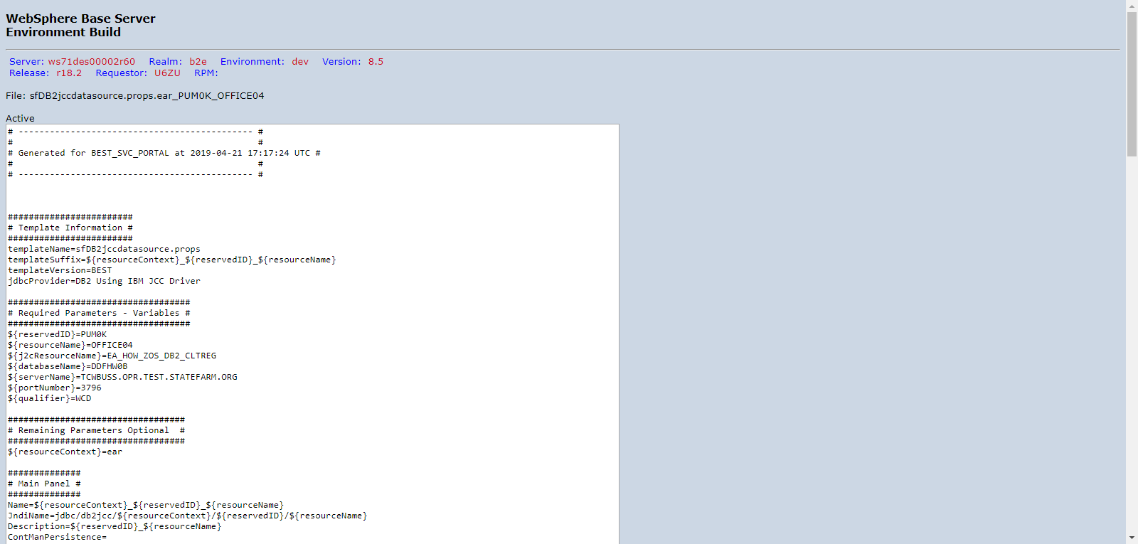

PUM0KD00_DVNTD_sfDB2jccdatasource.props.ear_PUM0K_OFFICE05.png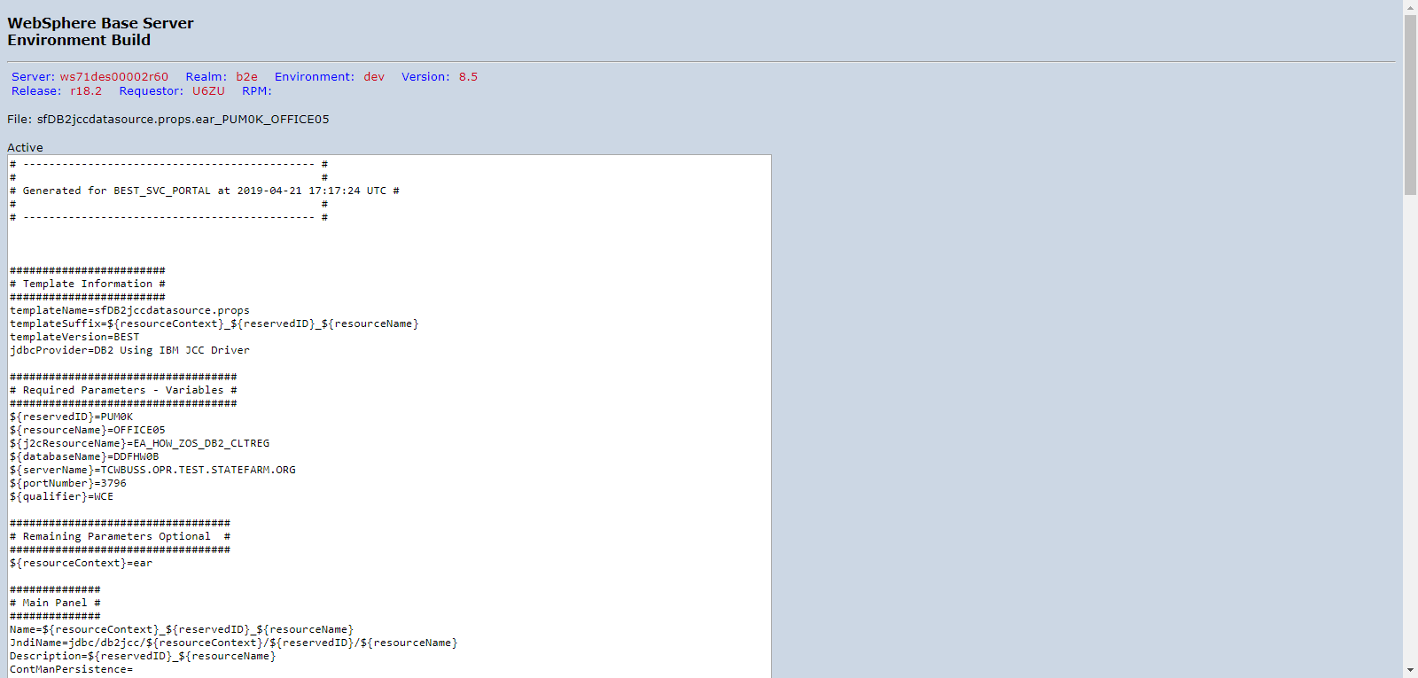

PUM0KD00_DVNTD_sfDB2jccdatasource.props.ear_PUM0K_OFFICE06.png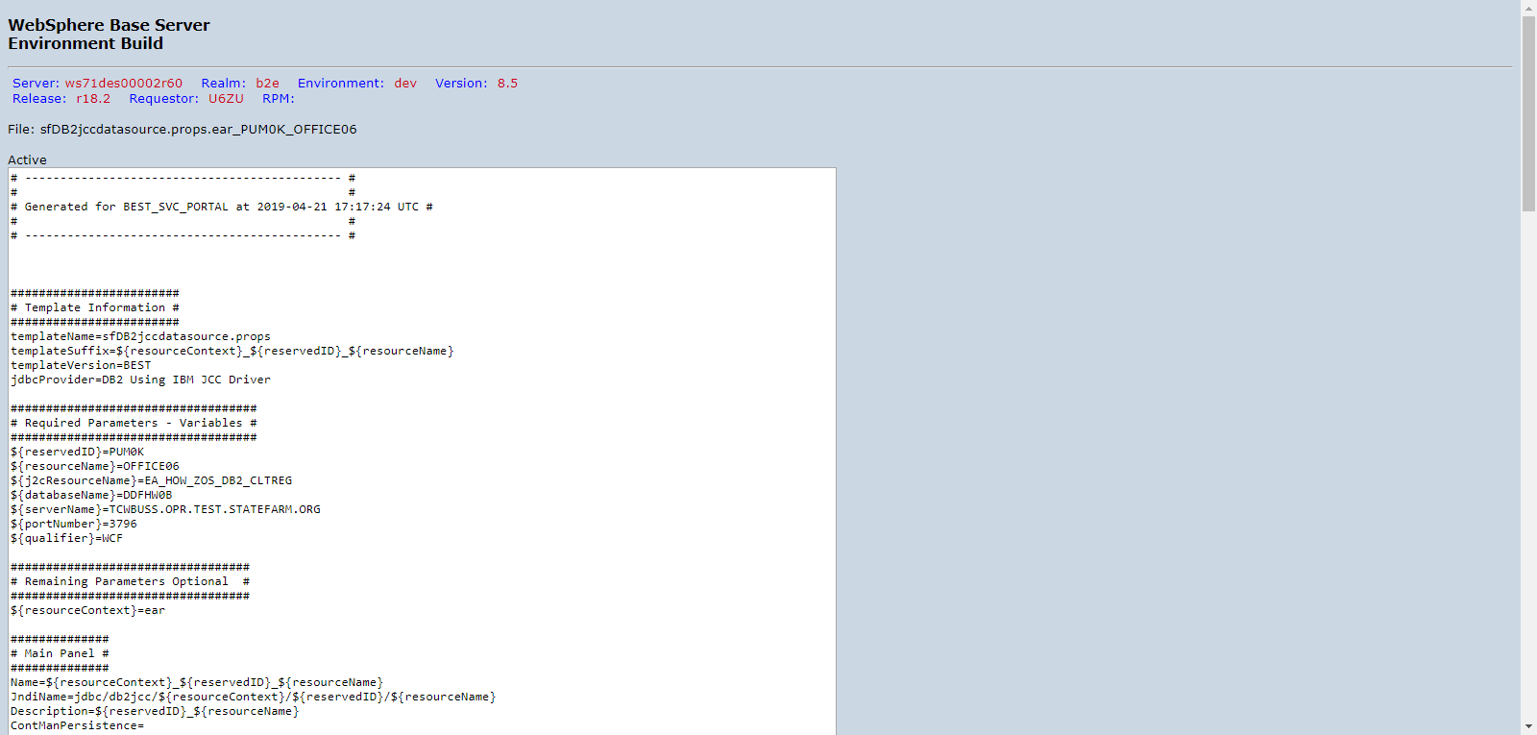

PUM0KD00_DVNTD_sfDB2jccdatasource.props.ear_PUM0K_OFFICE07.png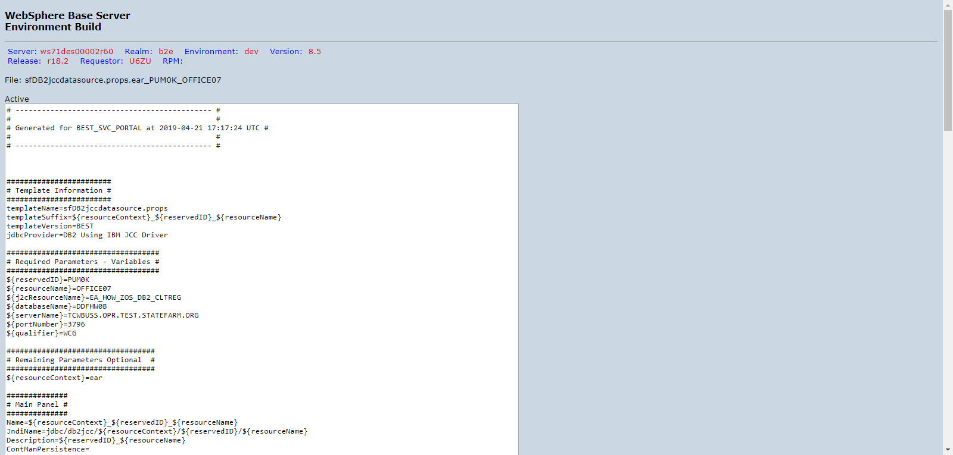

PUM0KD00_DVNTD_sfDB2jccdatasource.props.ear_PUM0K_OFFICE08.png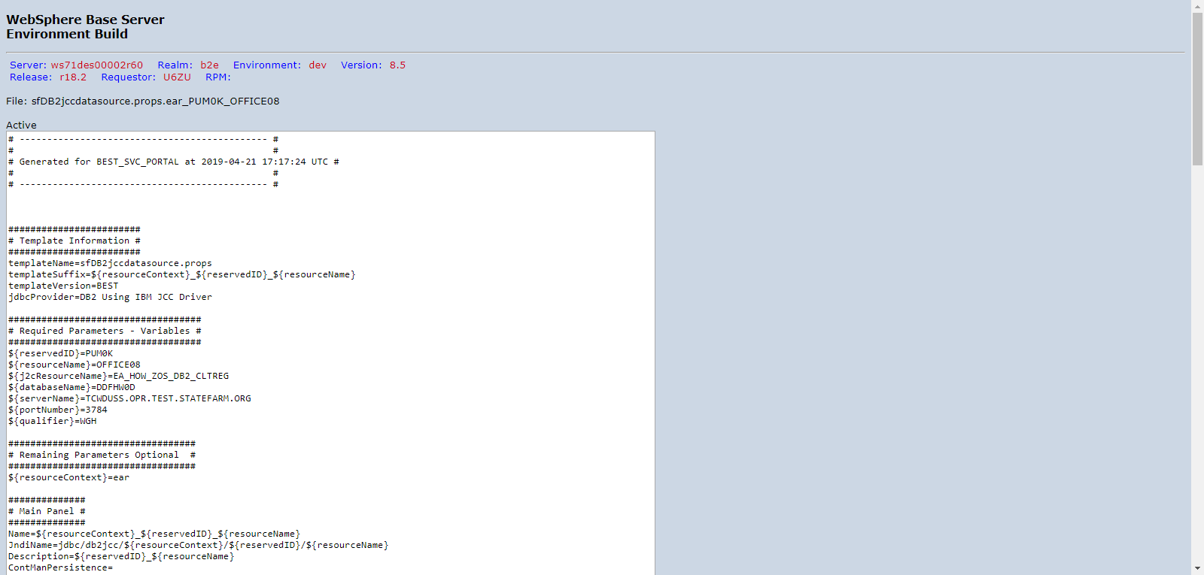

PUM0KD00_DVNTD_sfDB2jccdatasource.props.ear_PUM0K_OFFICE09.png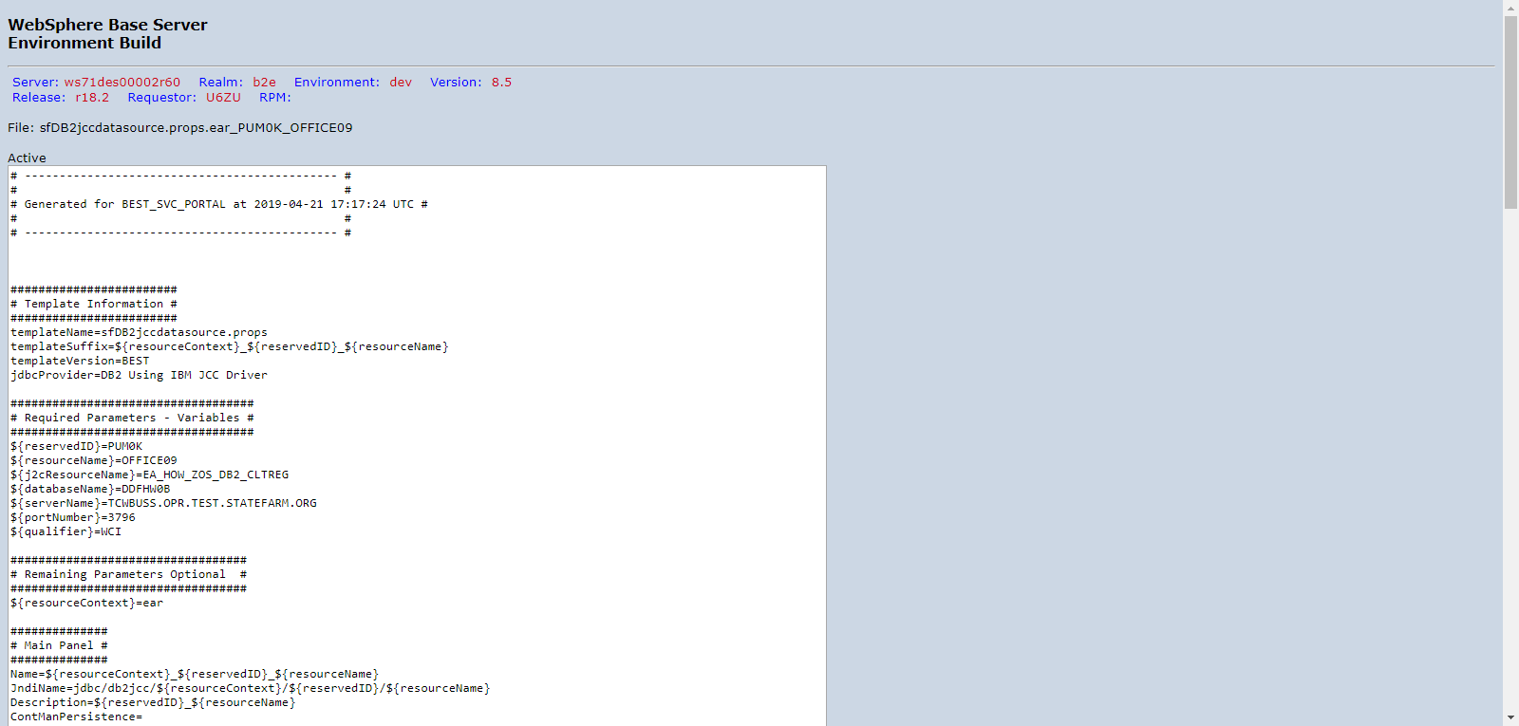

PUM0KD00_DVNTD_sfDB2jccdatasource.props.ear_PUM0K_OFFICE11.png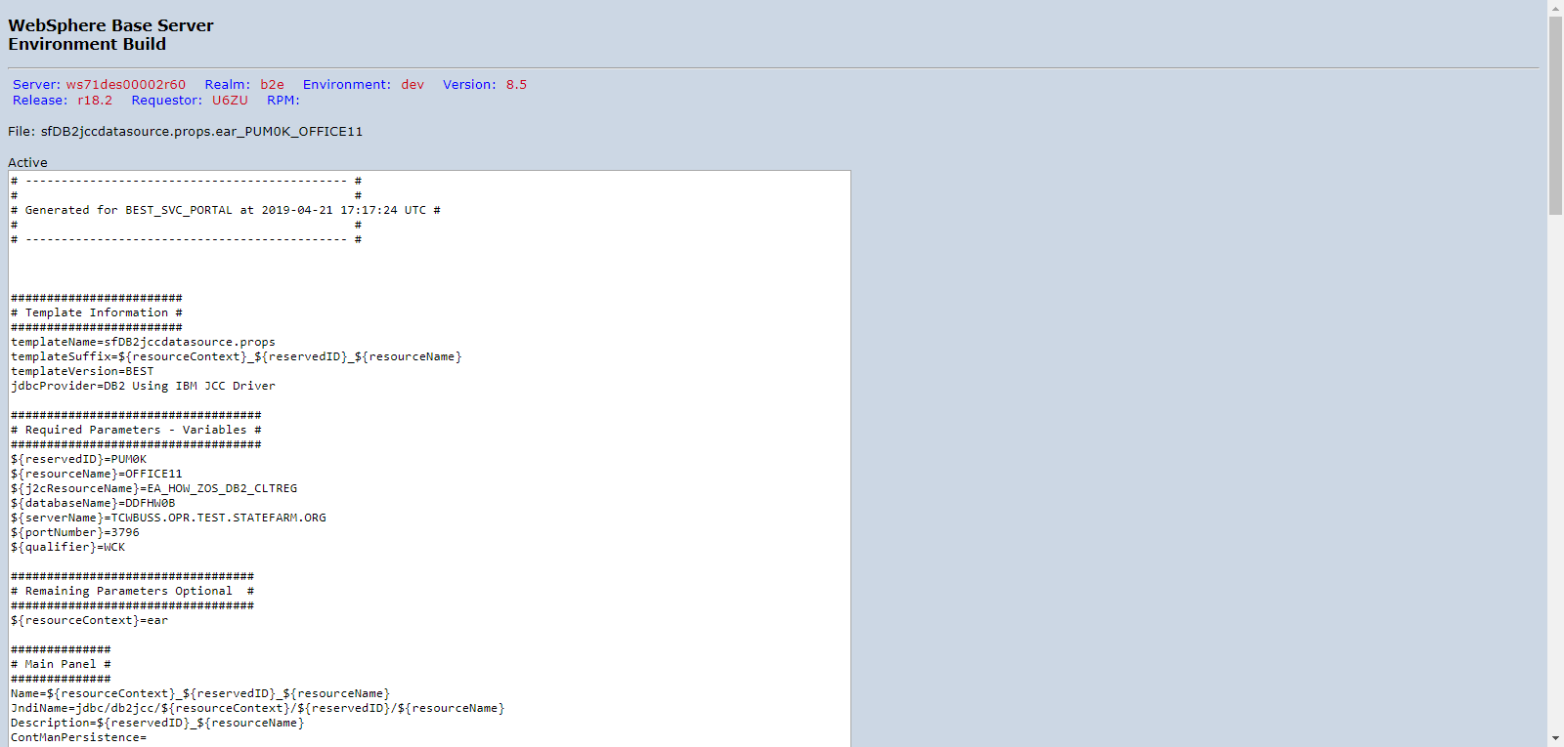

PUM0KD00_DVNTD_sfDB2jccdatasource.props.ear_PUM0K_OFFICE12.png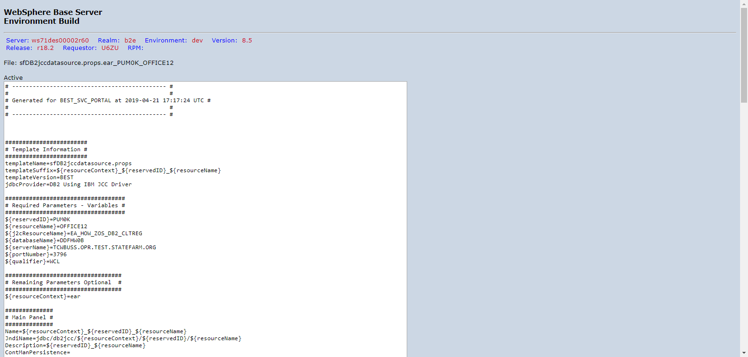

PUM0KD00_DVNTD_sfDB2jccdatasource.props.ear_PUM0K_OFFICE13.png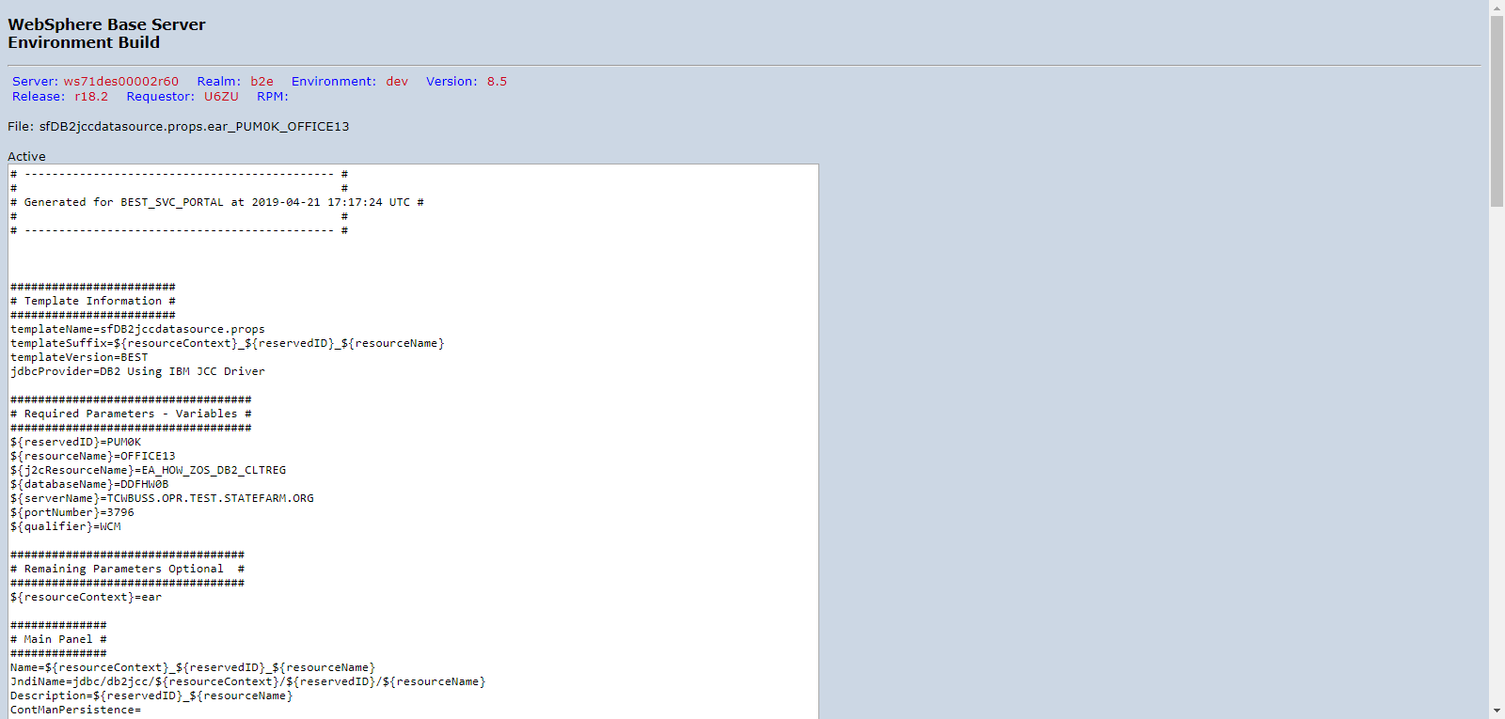

PUM0KD00_DVNTD_sfDB2jccdatasource.props.ear_PUM0K_OFFICE14.png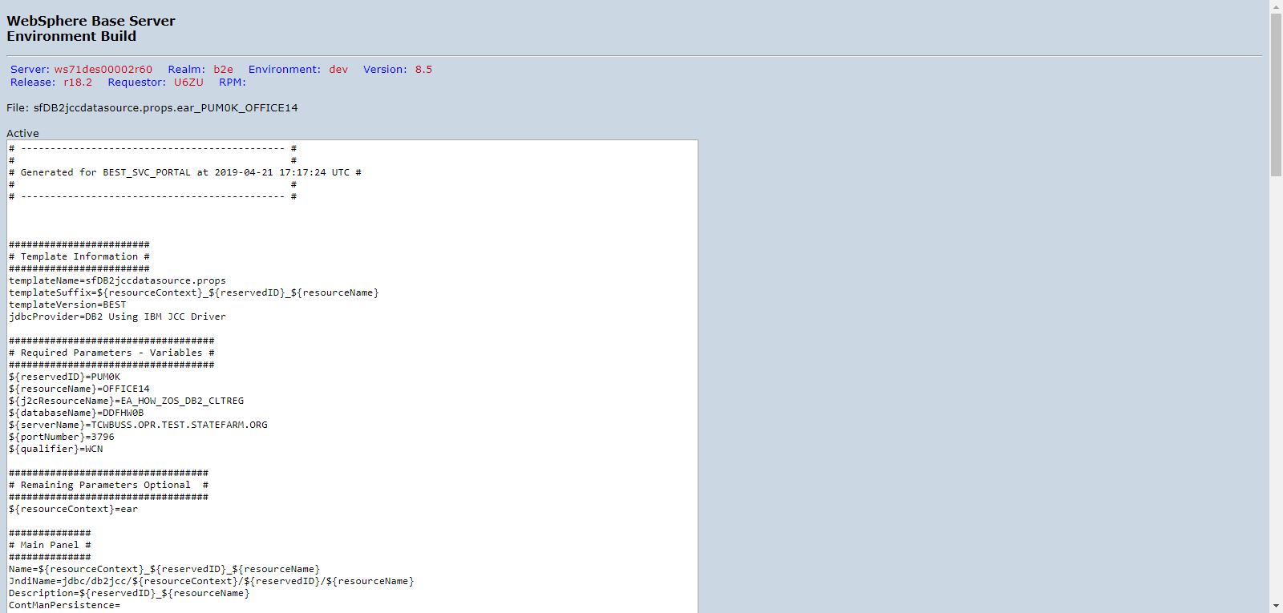

PUM0KD00_DVNTD_sfDB2jccdatasource.props.ear_PUM0K_OFFICE15.png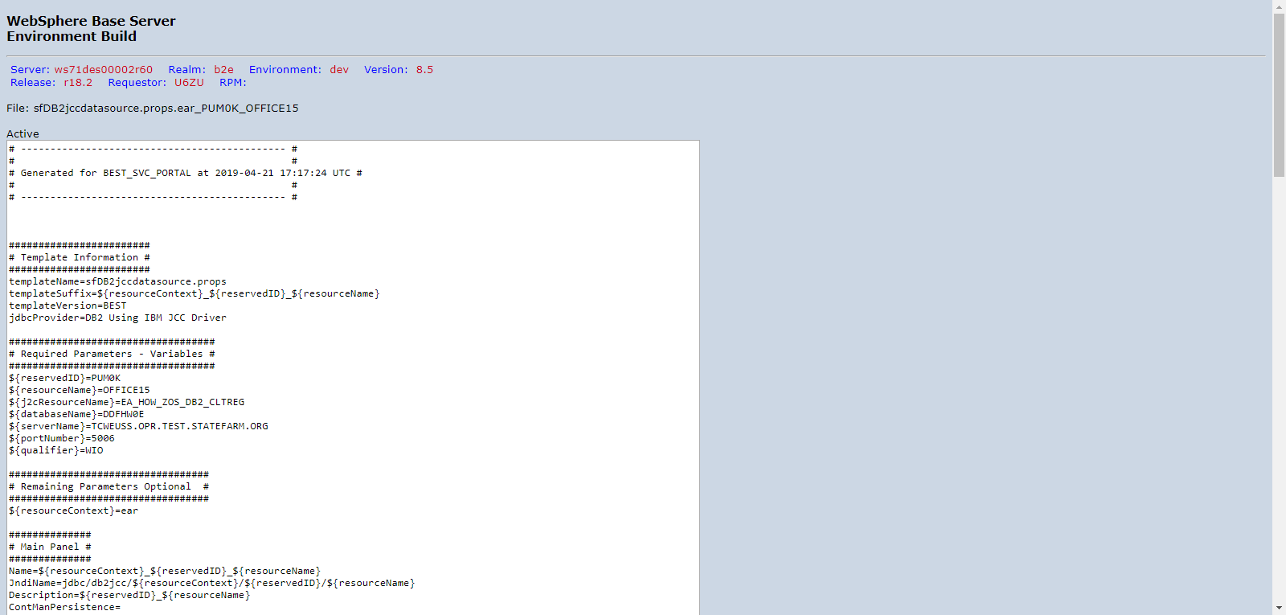

PUM0KD00_DVNTD_sfDB2jccdatasource.props.ear_PUM0K_OFFICE16.png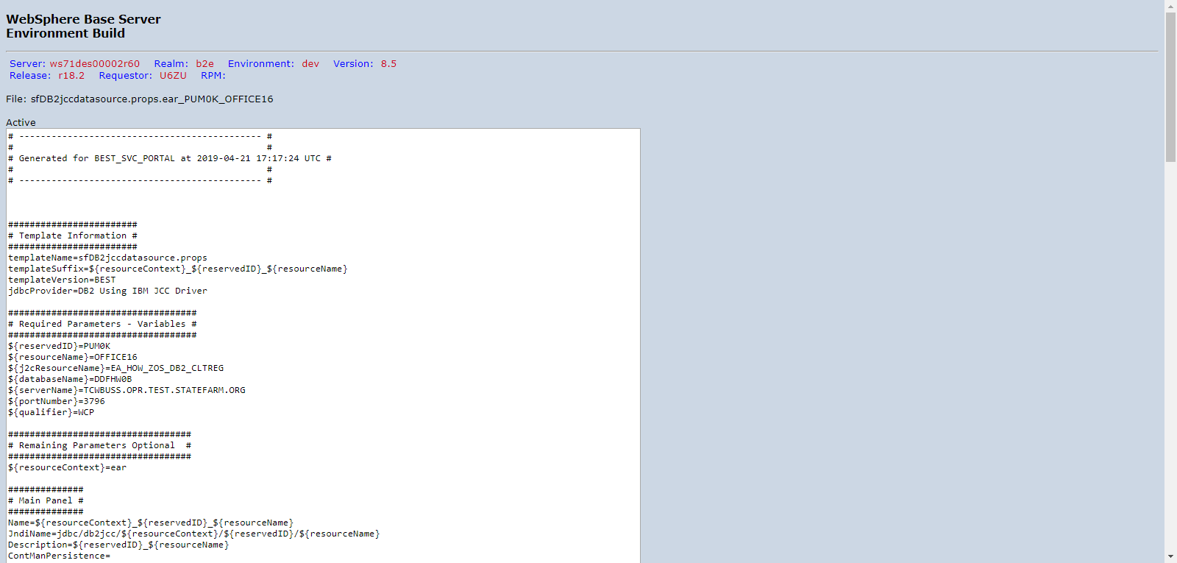

PUM0KD00_DVNTD_sfDB2jccdatasource.props.ear_PUM0K_OFFICE17.png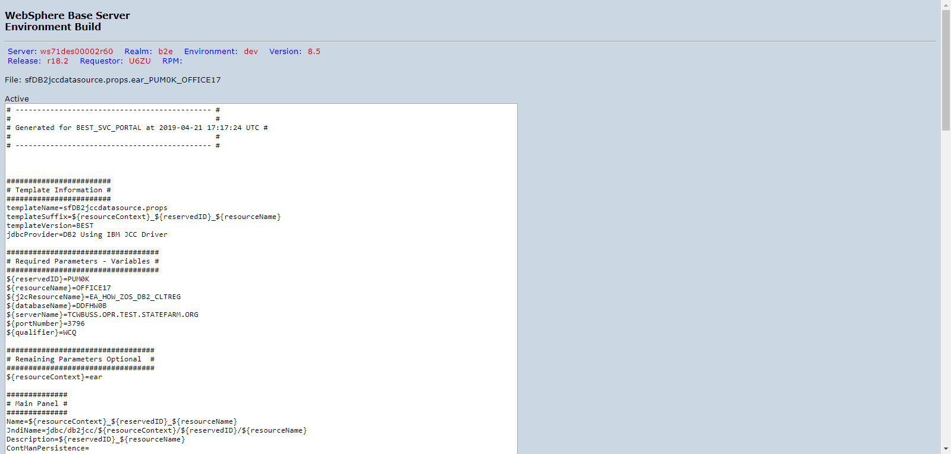

PUM0KD00_DVNTD_sfDB2jccdatasource.props.ear_PUM0K_OFFICE18.png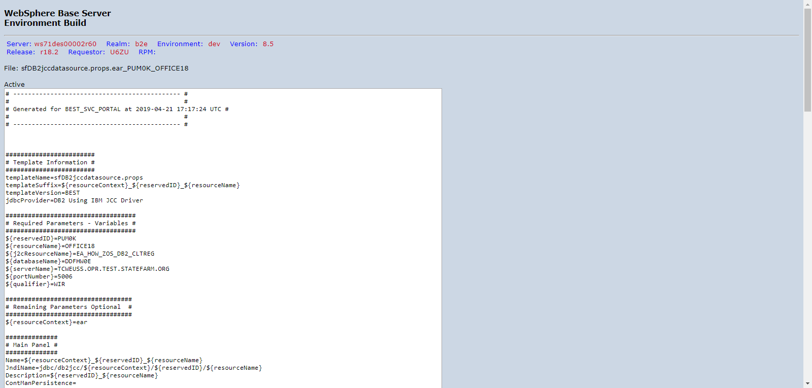

PUM0KD00_DVNTD_sfDB2jccdatasource.props.ear_PUM0K_OFFICE19.png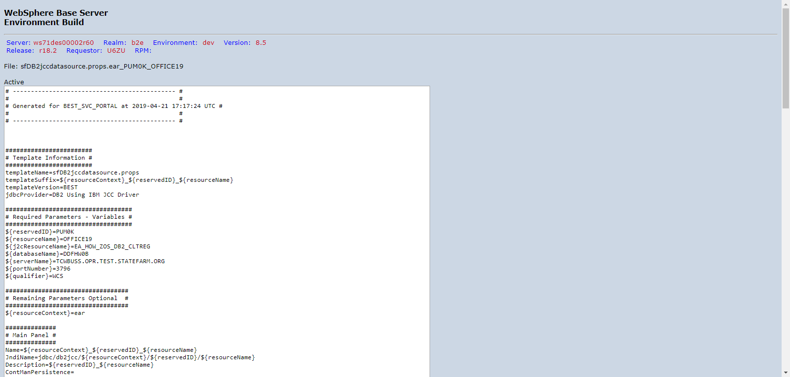

PUM0KD00_DVNTD_sfDB2jccdatasource.props.ear_PUM0K_OFFICE20.png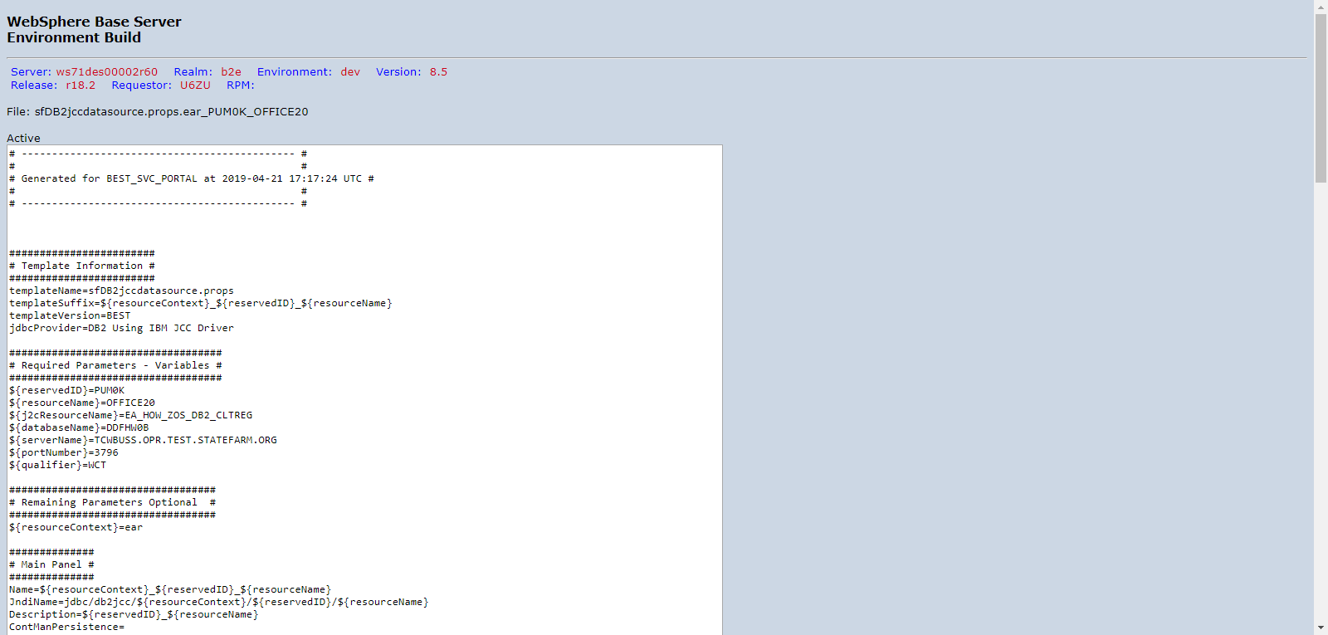

PUM0KD00_DVNTD_sfDB2jccdatasource.props.ear_PUM0K_OFFICE21.png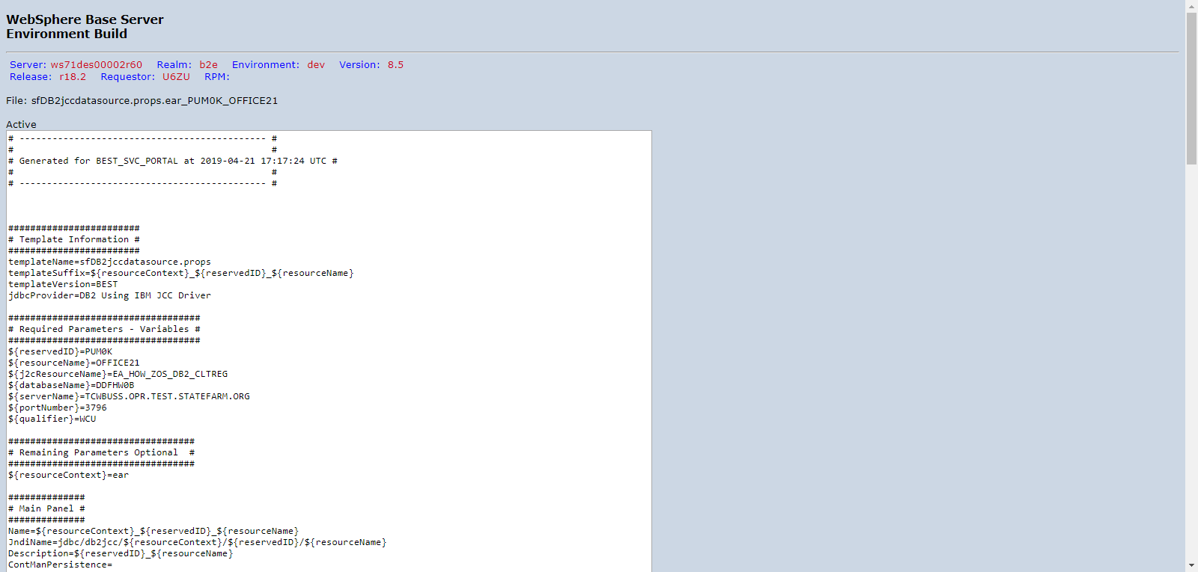

PUM0KD00_DVNTD_sfDB2jccdatasource.props.ear_PUM0K_OFFICE22.png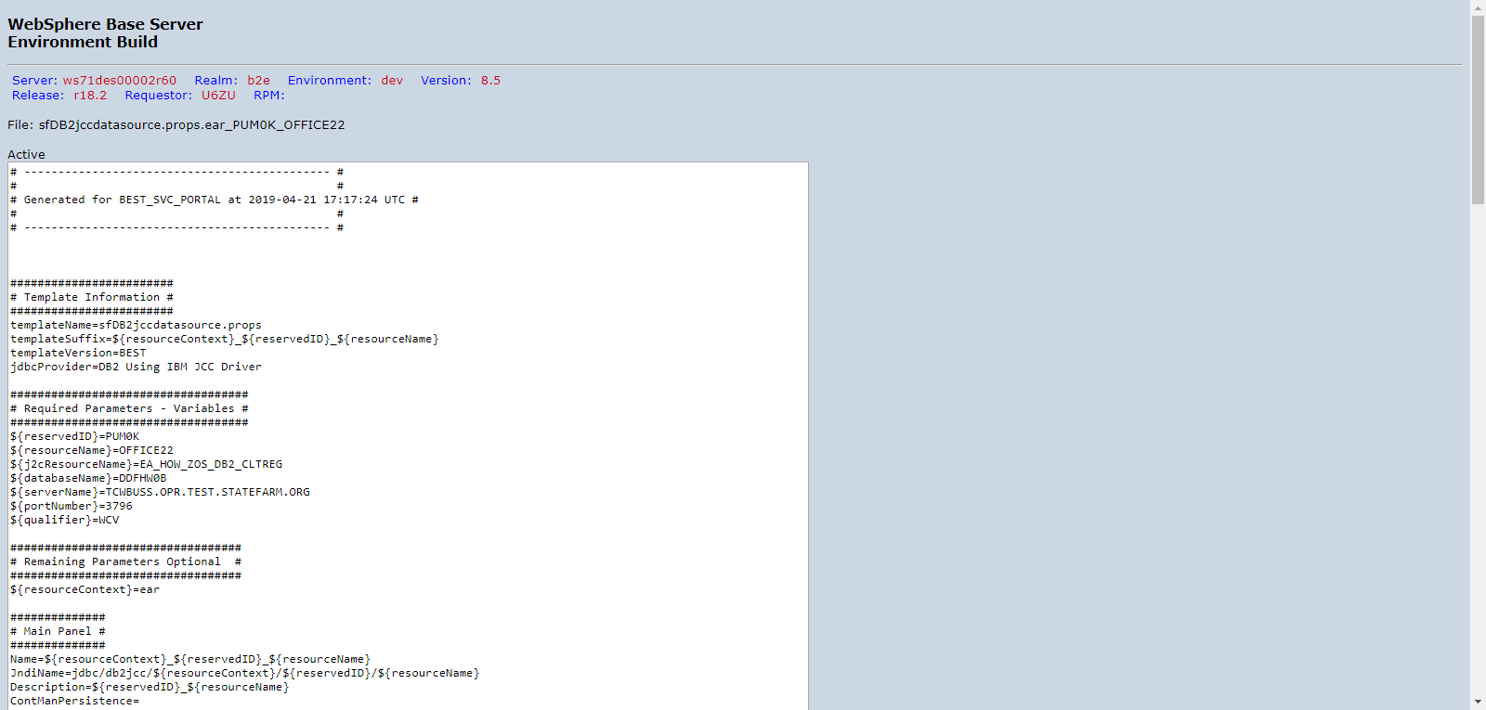

PUM0KD00_DVNTD_sfDB2jccdatasource.props.ear_PUM0K_OFFICE23.png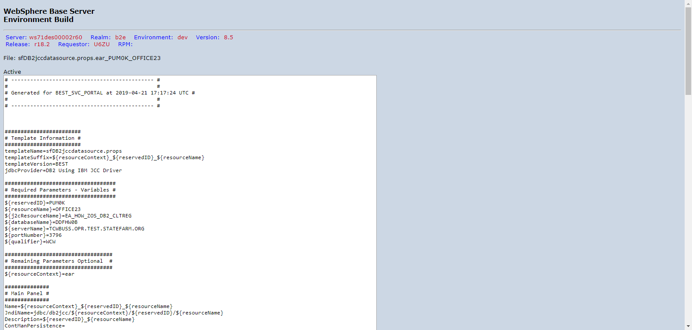

PUM0KD00_DVNTD_sfDB2jccdatasource.props.ear_PUM0K_OFFICE24.png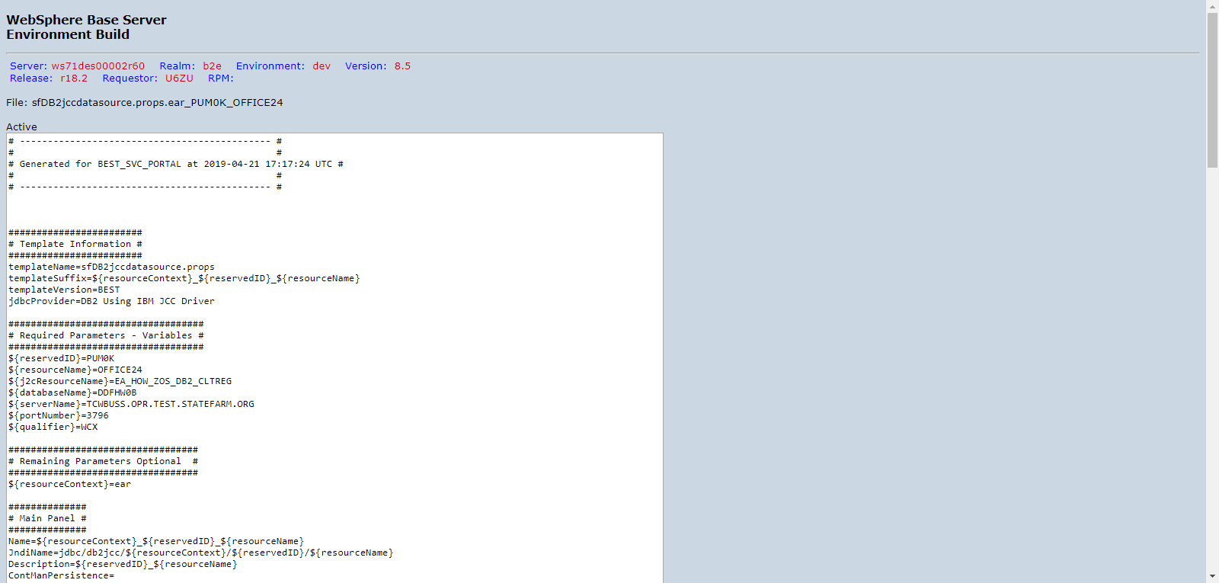

PUM0KD00_DVNTD_sfDB2jccdatasource.props.ear_PUM0K_OFFICE25.png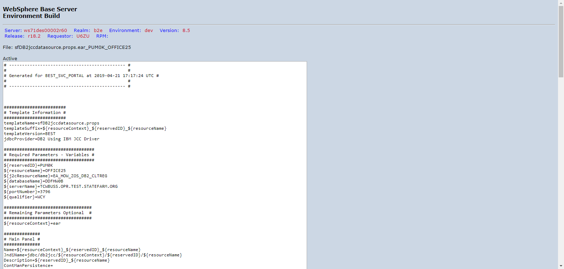

PUM0KD00_DVNTD_sfDB2jccdatasource.props.ear_PUM0K_OFFICE26.png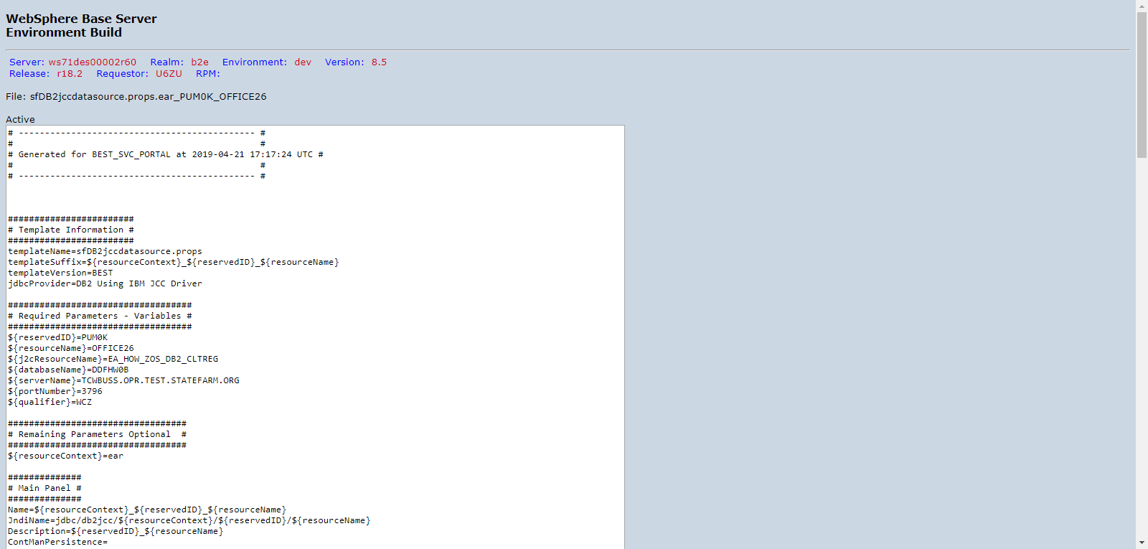

PUM0KD00_DVNTD_sfDB2jccdatasource.props.ear_PUM0K_OFFICE27.png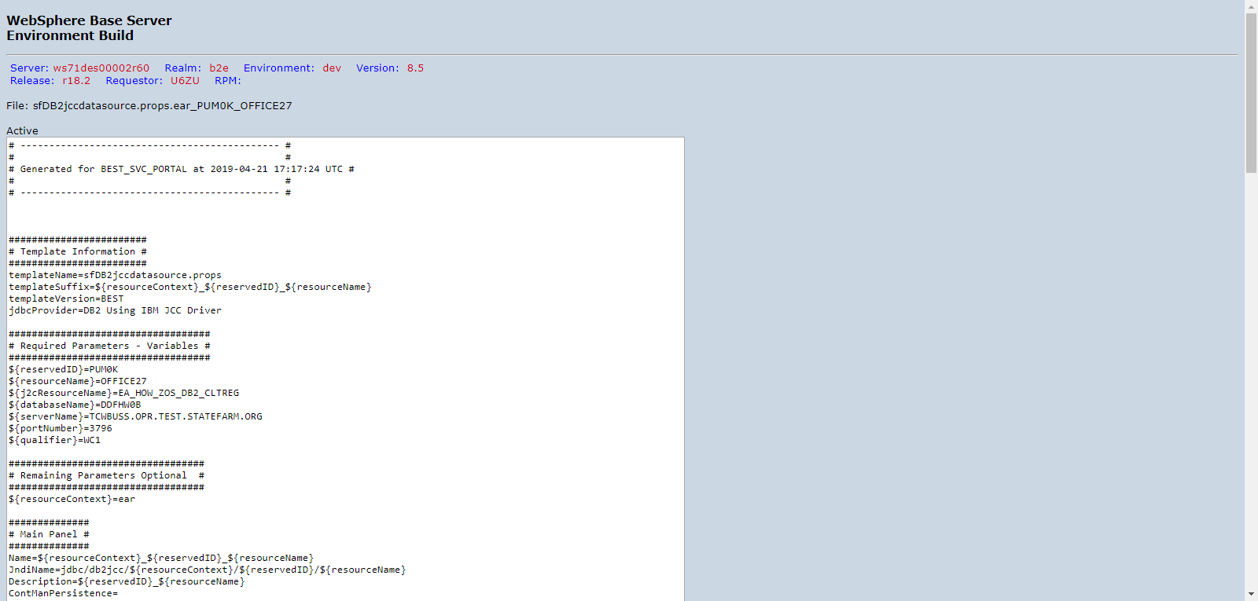

PUM0KD00_DVNTD_sfDB2jccdatasource.props.ear_PUM0K_OFFICE28.png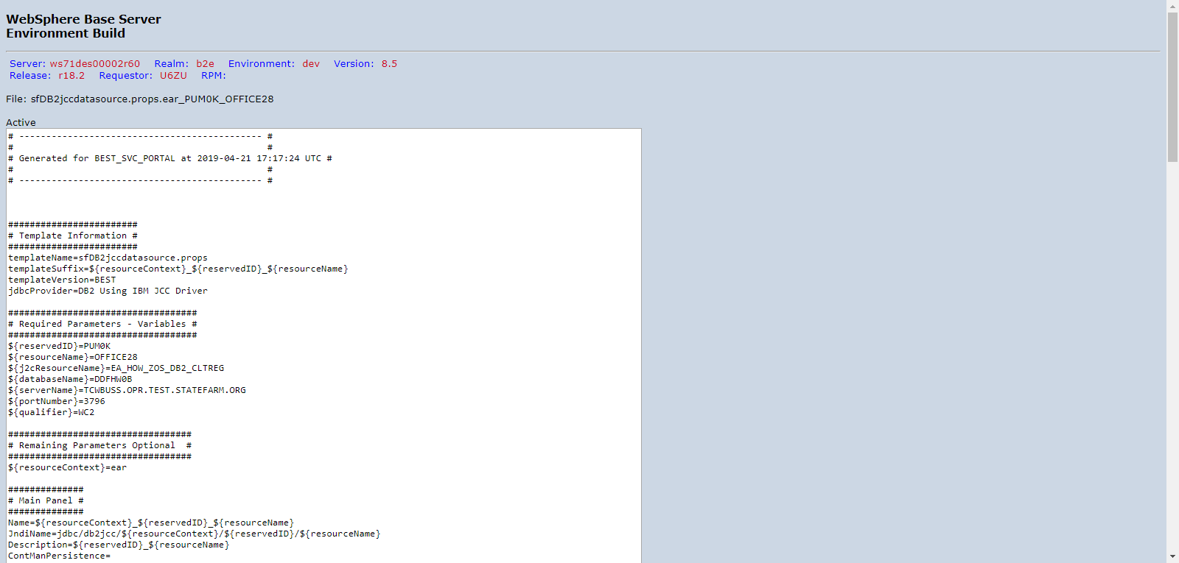

PUM0KD00_DVNTD_sfDB2jccdatasource.props.ear_PUM0K_OFFICE73.png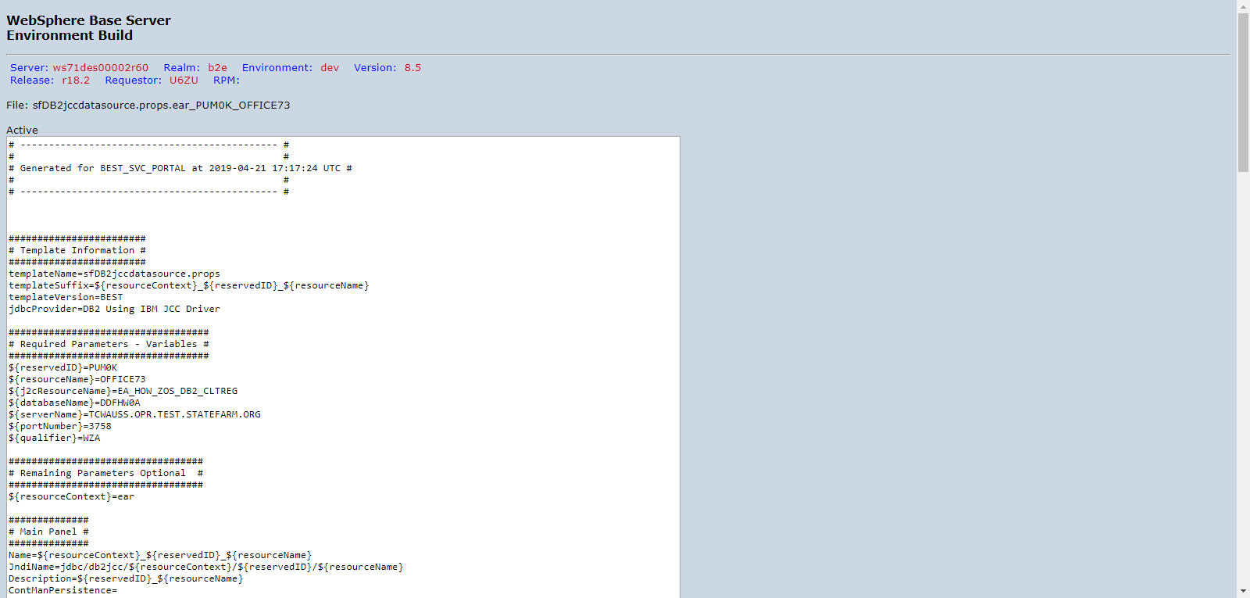

PUM0KD00_DVNTD_sfDB2jccdatasource.props.ear_PUM0K_OFFICE74.png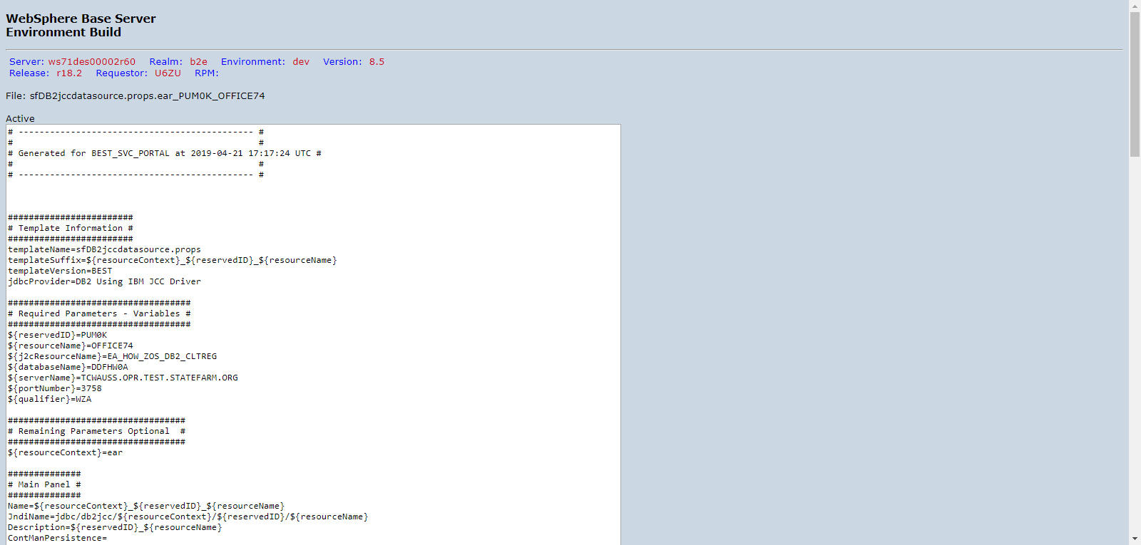

PUM0KD00_DVNTD_sfDB2jccdatasource.props.ear_PUM0K_OFFICE75.png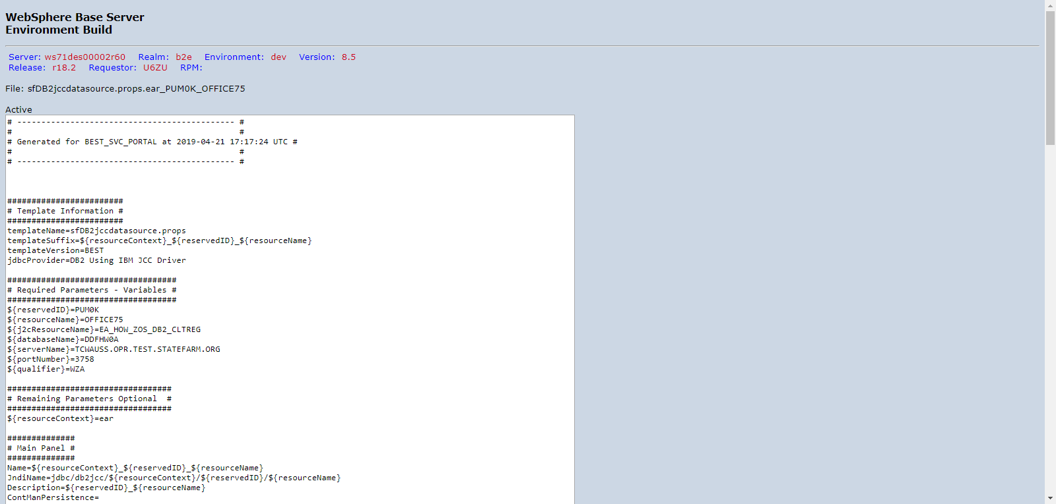

PUM0KD00_DVNTD_sfIMSConnectionfactory.props.ear_PUM0K_IMSRO00.png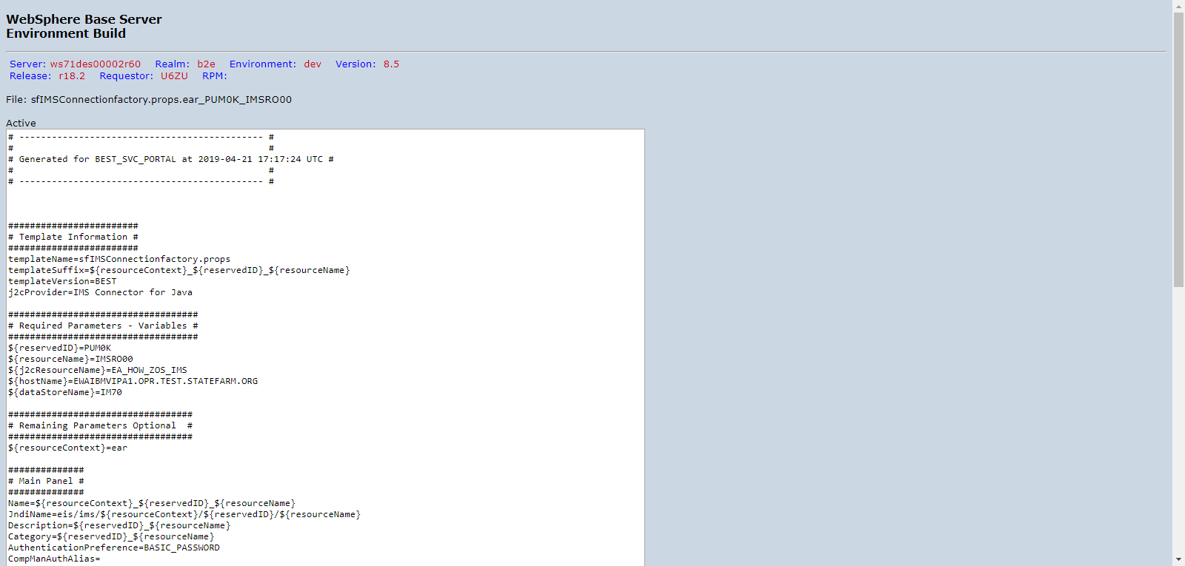

PUM0KD00_DVNTD_sfIMSConnectionfactory.props.ear_PUM0K_IMSRO01.png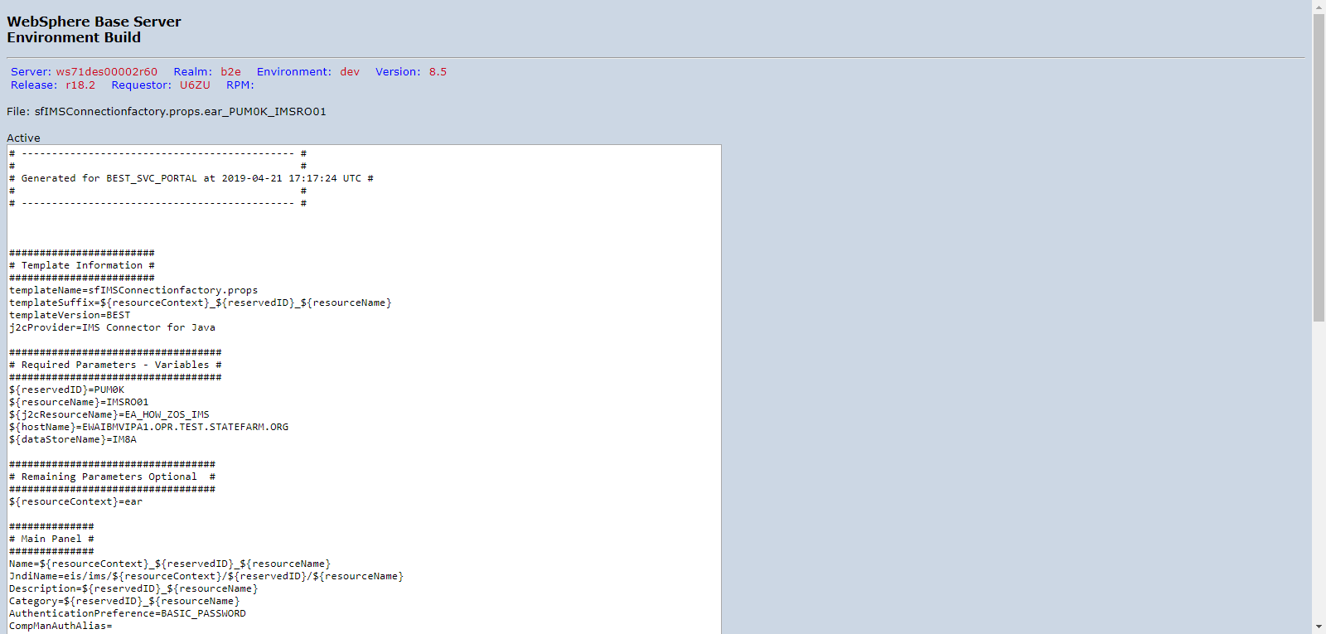

PUM0KD00_DVNTD_sfIMSConnectionfactory.props.ear_PUM0K_IMSRO02.png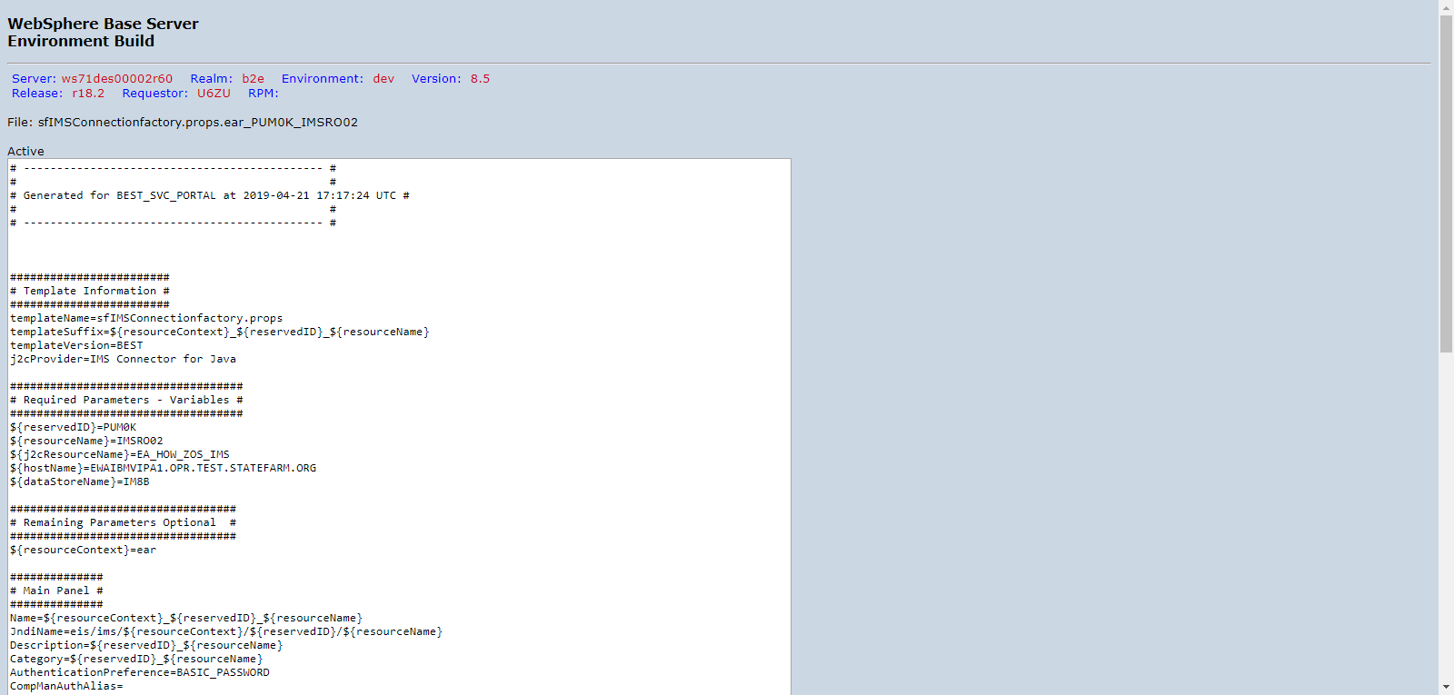

PUM0KD00_DVNTD_sfIMSConnectionfactory.props.ear_PUM0K_IMSRO03.png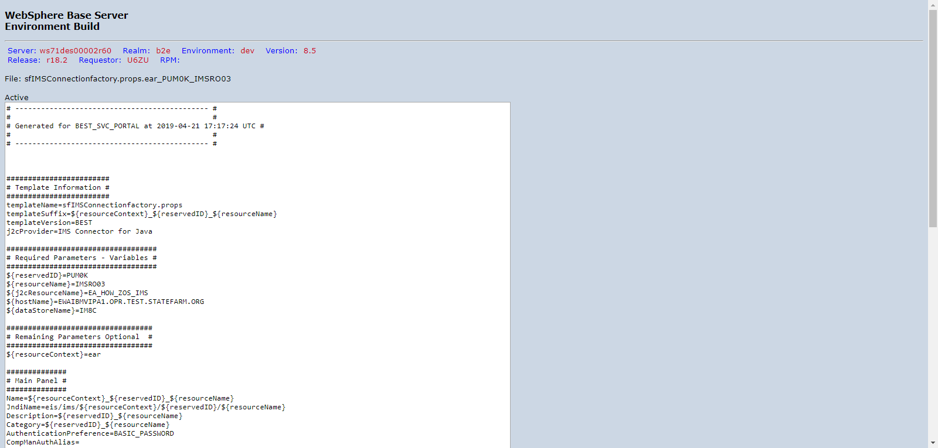

PUM0KD00_DVNTD_sfIMSConnectionfactory.props.ear_PUM0K_IMSRO04.png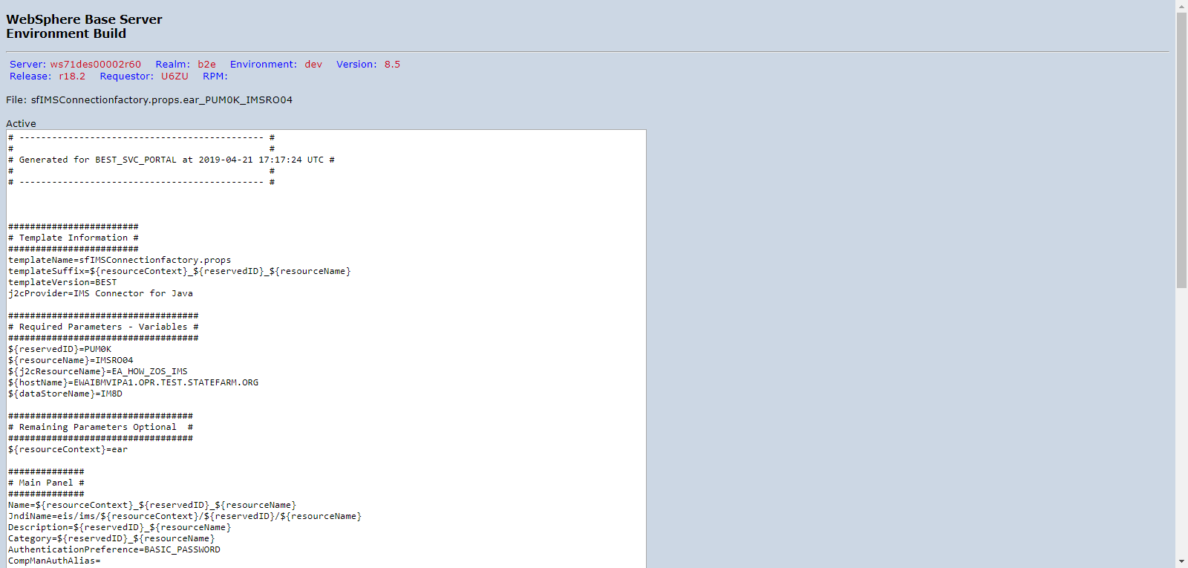

PUM0KD00_DVNTD_sfIMSConnectionfactory.props.ear_PUM0K_IMSRO05.png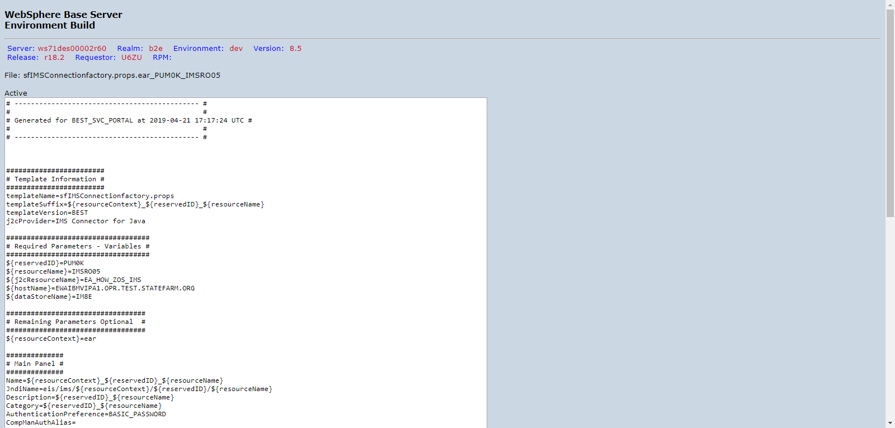

PUM0KD00_DVNTD_sfIMSConnectionfactory.props.ear_PUM0K_IMSRO06.png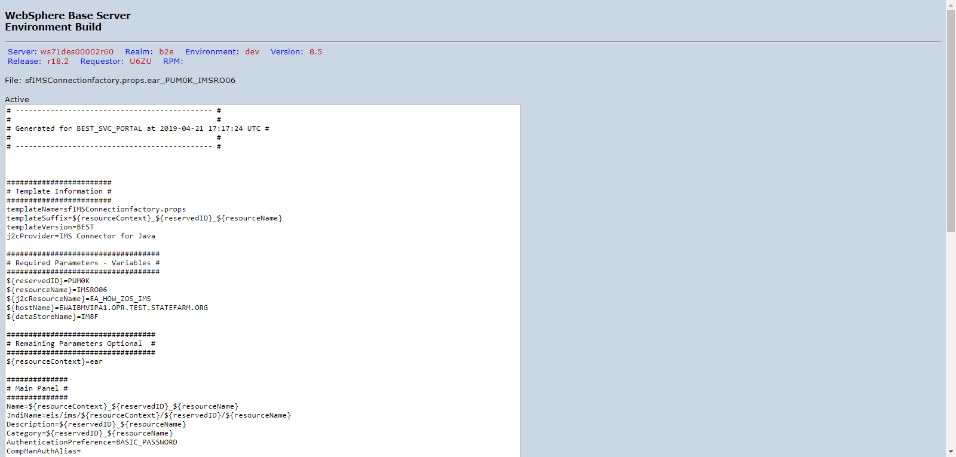

PUM0KD00_DVNTD_sfIMSConnectionfactory.props.ear_PUM0K_IMSRO07.png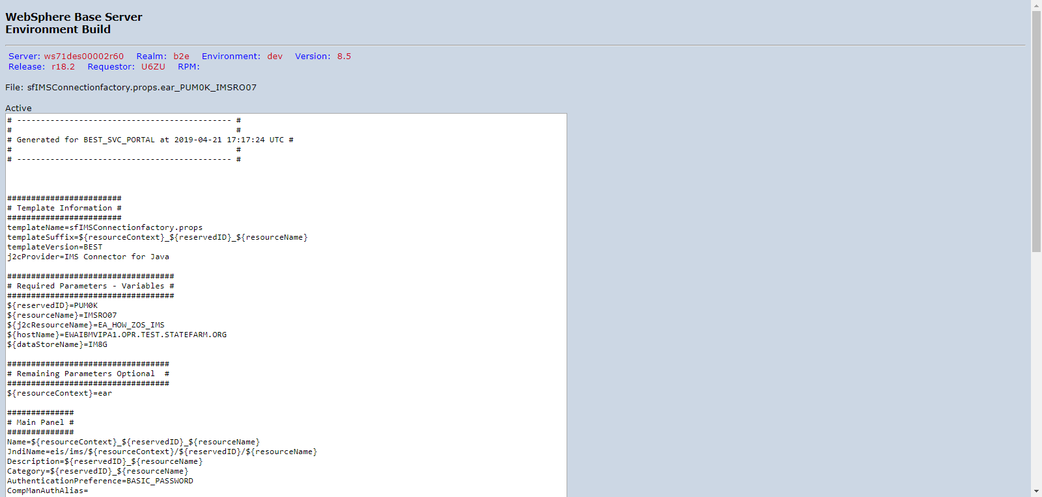

PUM0KD00_DVNTD_sfIMSConnectionfactory.props.ear_PUM0K_IMSRO08.png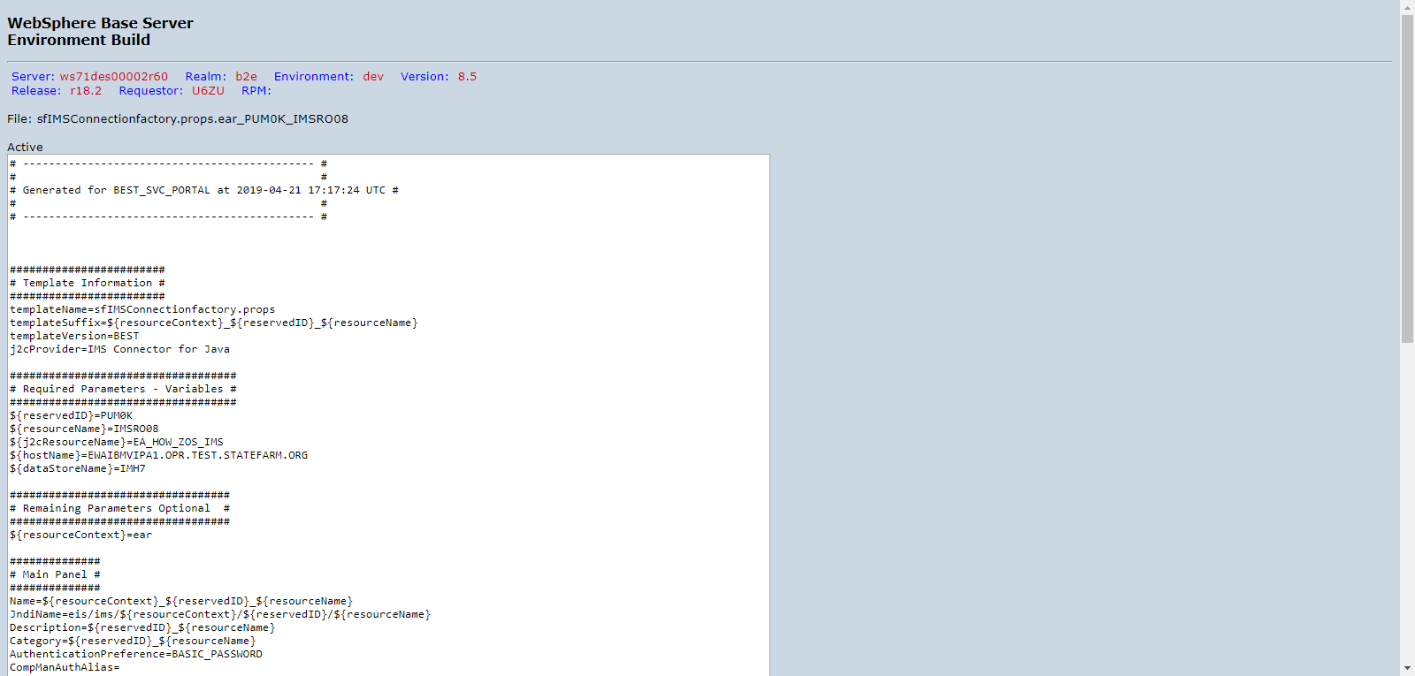

PUM0KD00_DVNTD_sfIMSConnectionfactory.props.ear_PUM0K_IMSRO09.png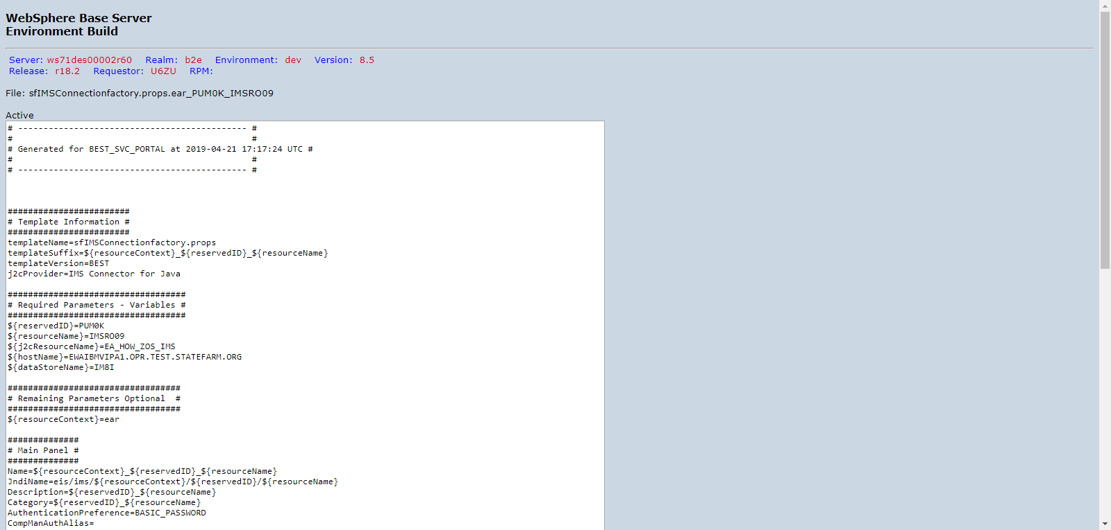

PUM0KD00_DVNTD_sfIMSConnectionfactory.props.ear_PUM0K_IMSRO11.png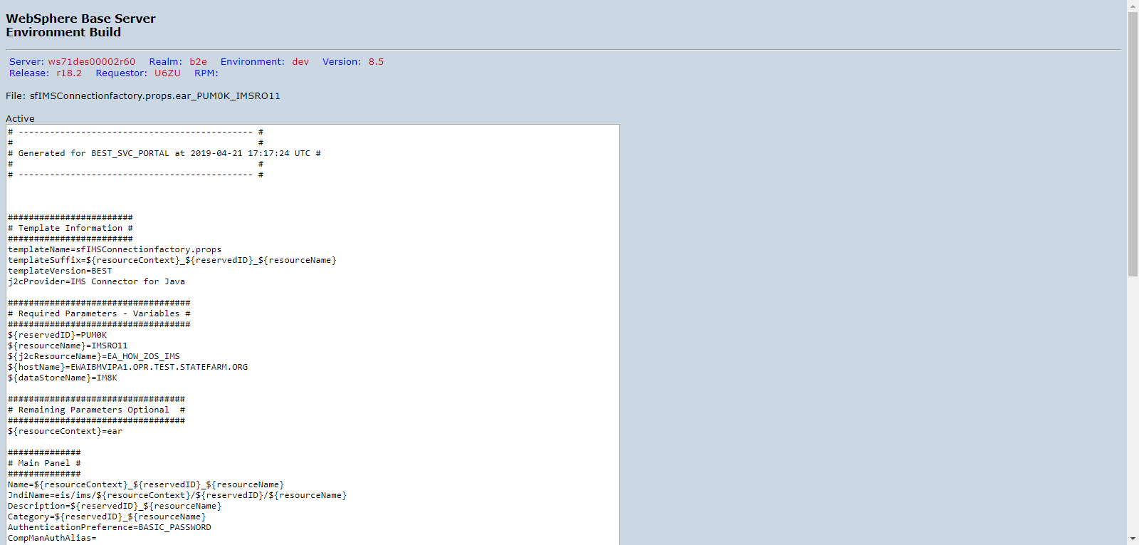

PUM0KD00_DVNTD_sfIMSConnectionfactory.props.ear_PUM0K_IMSRO12.png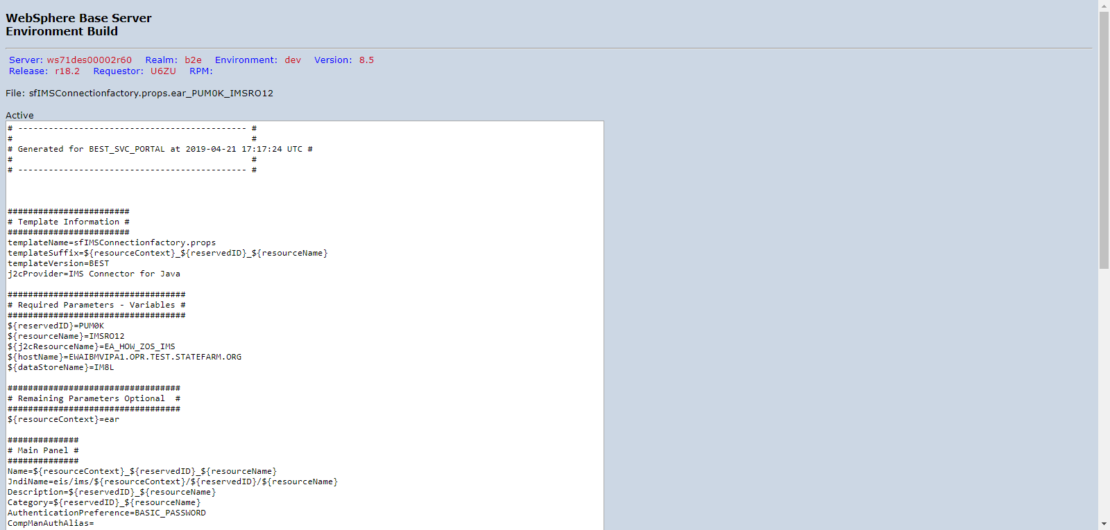

PUM0KD00_DVNTD_sfIMSConnectionfactory.props.ear_PUM0K_IMSRO13.png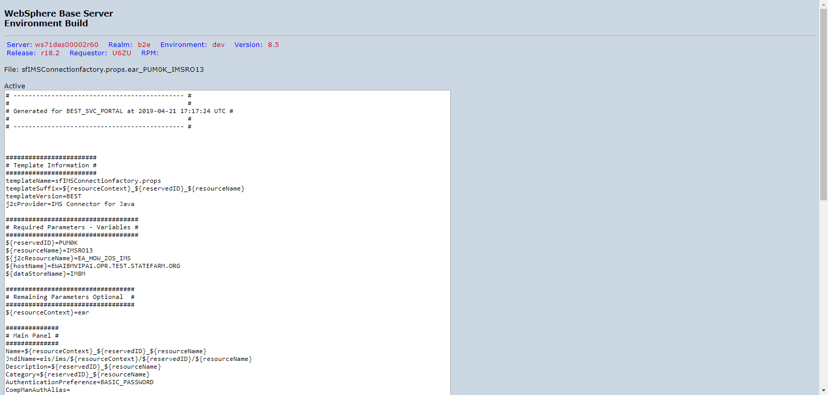

PUM0KD00_DVNTD_sfIMSConnectionfactory.props.ear_PUM0K_IMSRO14.png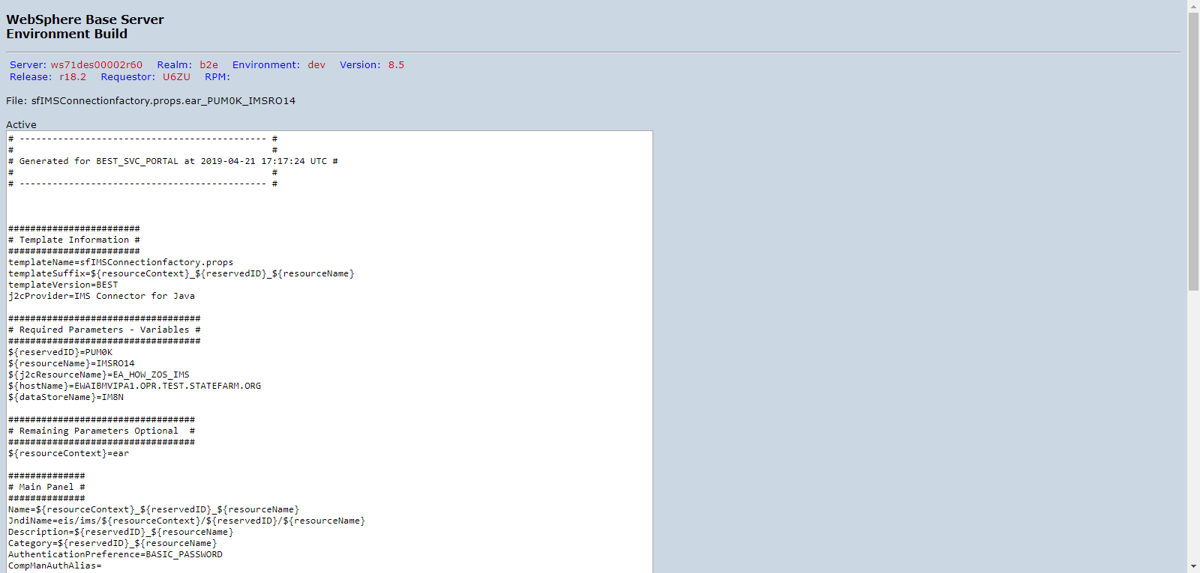

PUM0KD00_DVNTD_sfIMSConnectionfactory.props.ear_PUM0K_IMSRO15.png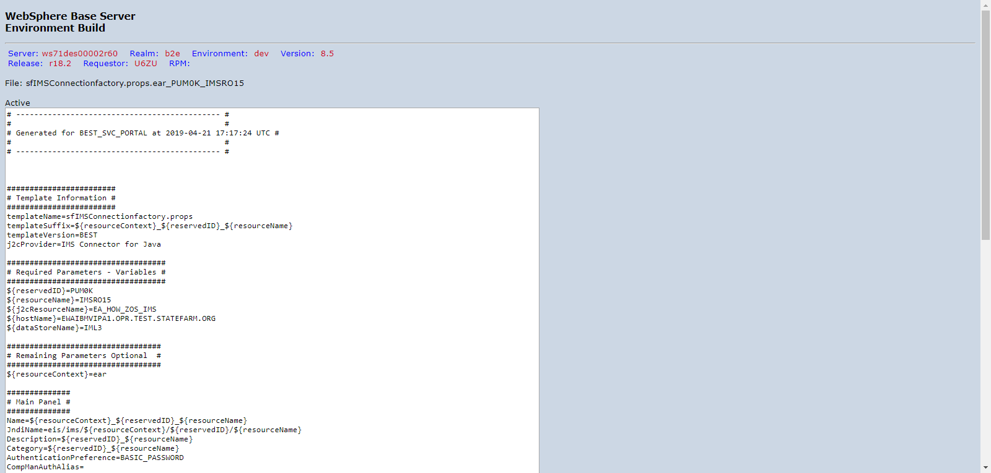

PUM0KD00_DVNTD_sfIMSConnectionfactory.props.ear_PUM0K_IMSRO16.png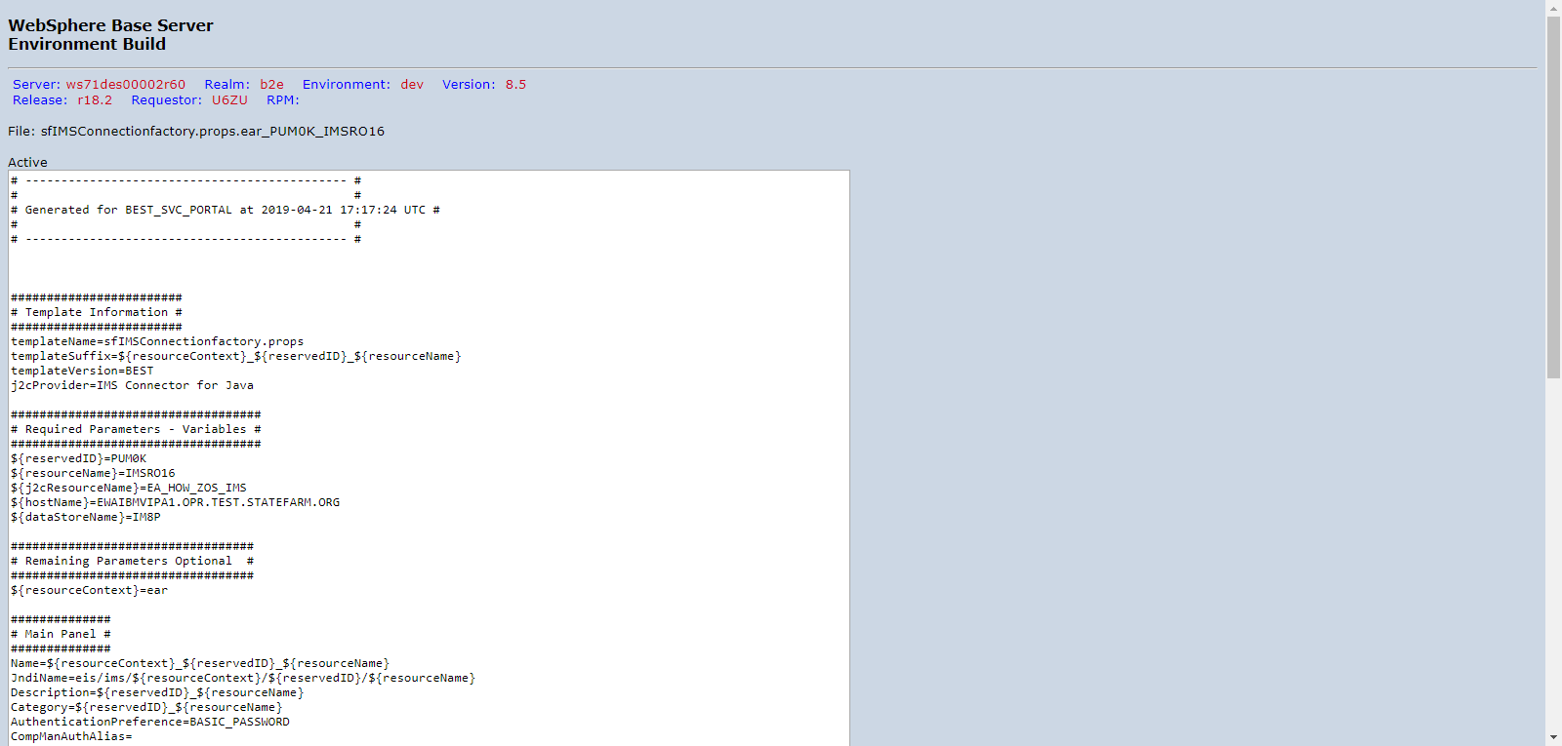

PUM0KD00_DVNTD_sfIMSConnectionfactory.props.ear_PUM0K_IMSRO17.png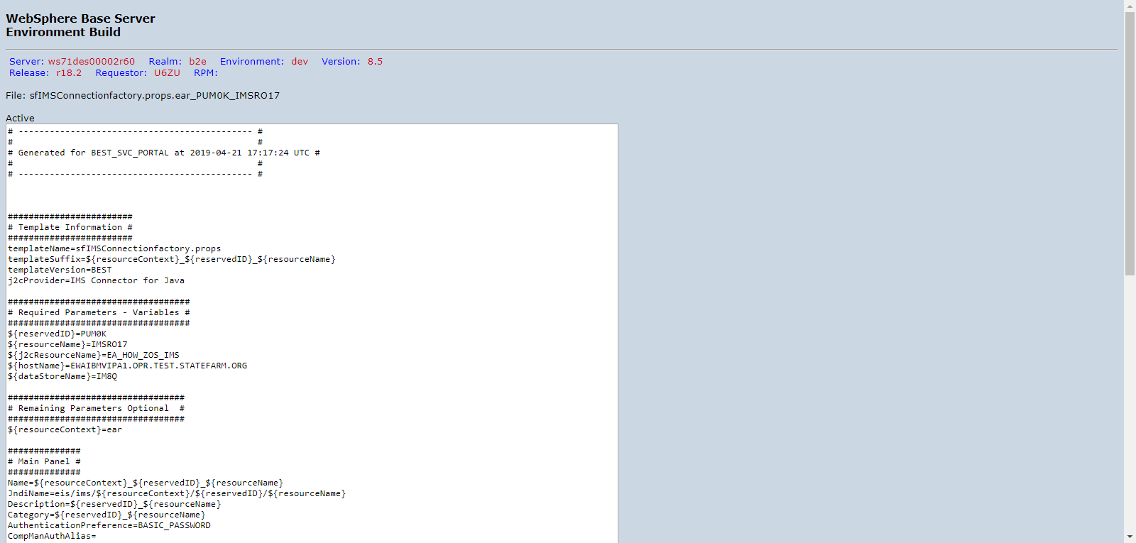

PUM0KD00_DVNTD_sfIMSConnectionfactory.props.ear_PUM0K_IMSRO18.png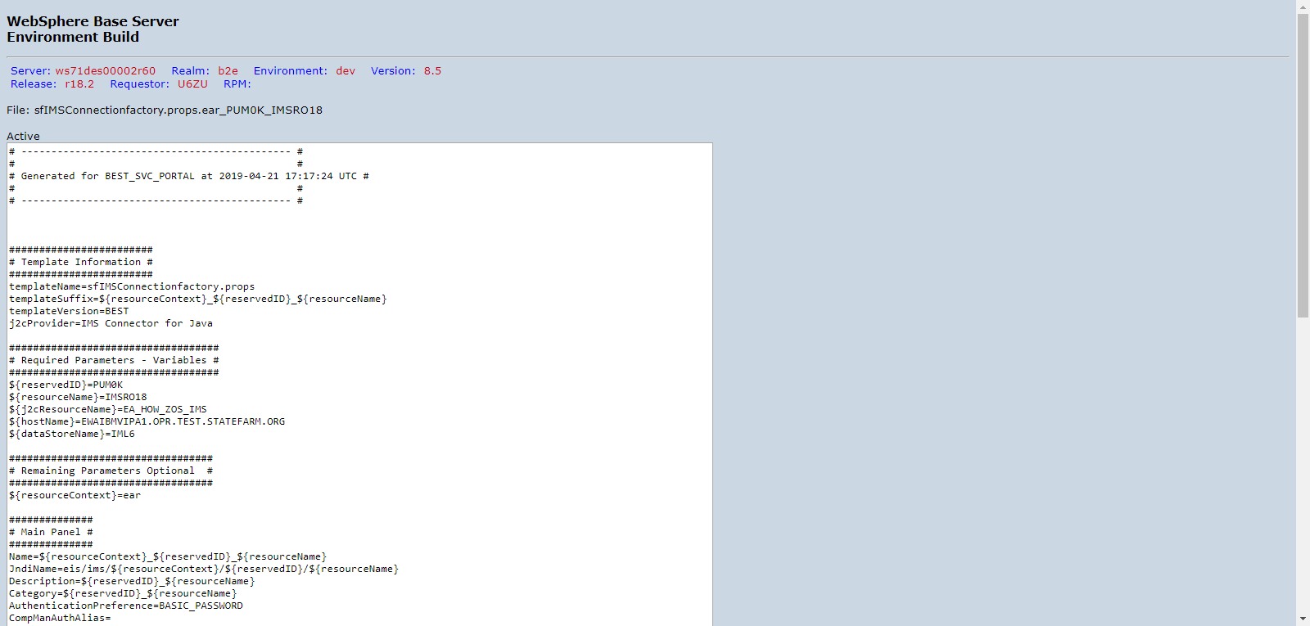

PUM0KD00_DVNTD_sfIMSConnectionfactory.props.ear_PUM0K_IMSRO19.png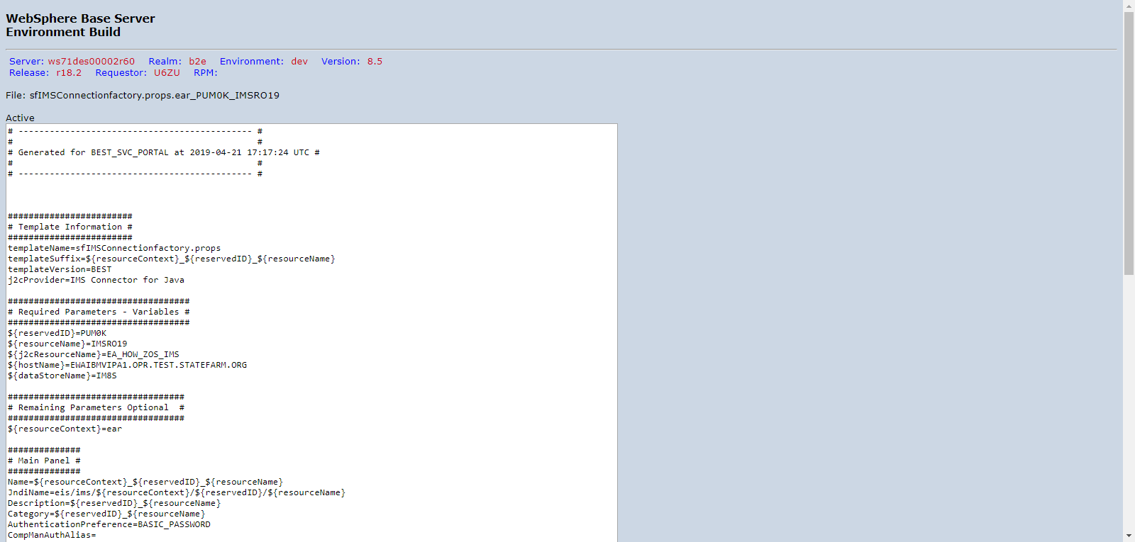

PUM0KD00_DVNTD_sfIMSConnectionfactory.props.ear_PUM0K_IMSRO20.png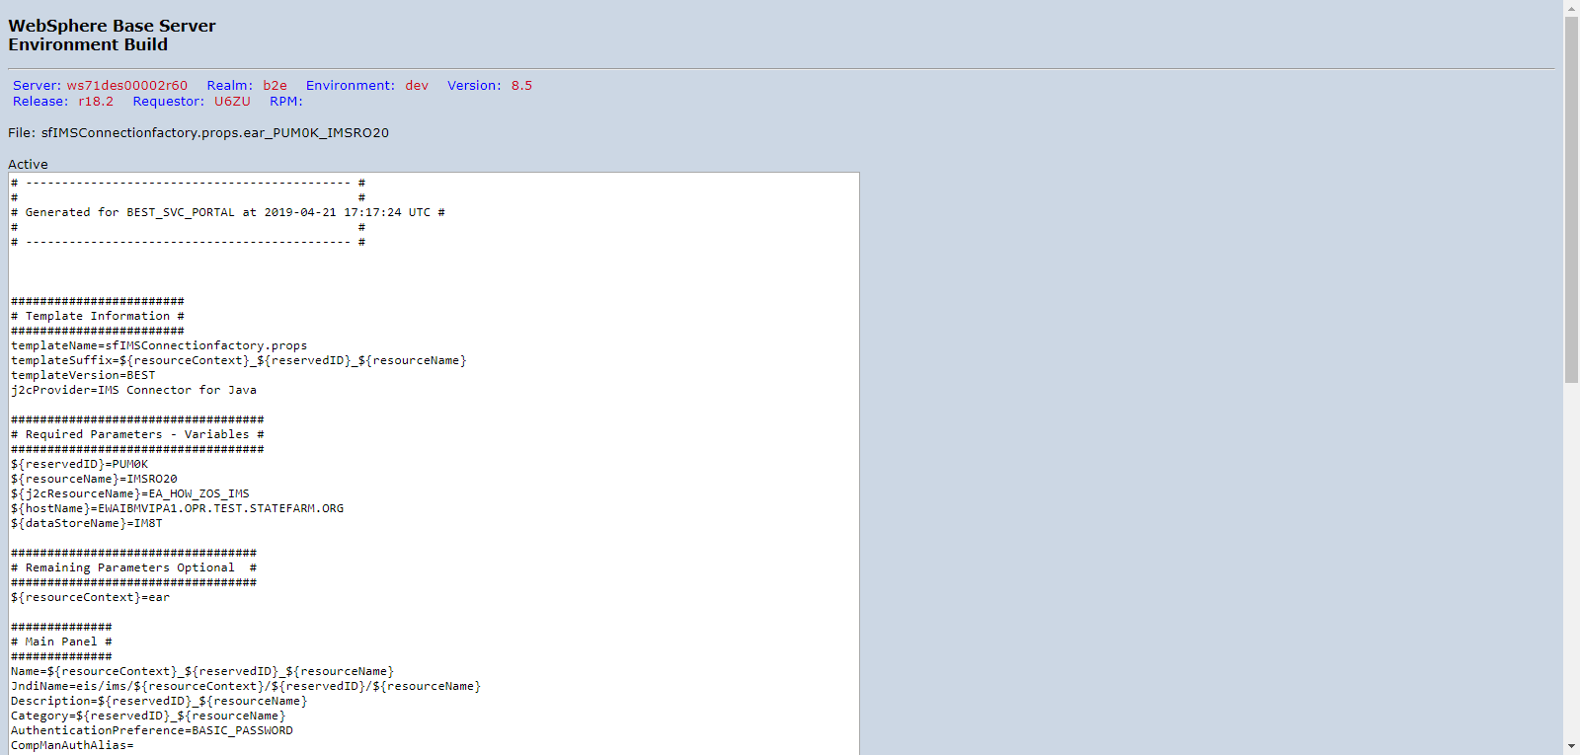

PUM0KD00_DVNTD_sfIMSConnectionfactory.props.ear_PUM0K_IMSRO21.png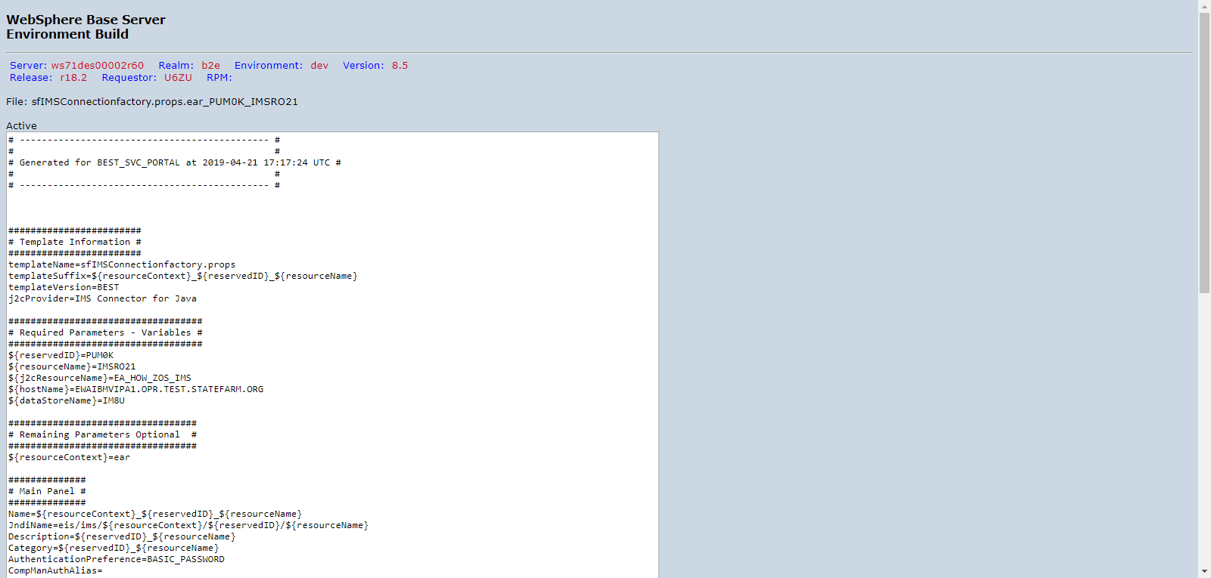

PUM0KD00_DVNTD_sfIMSConnectionfactory.props.ear_PUM0K_IMSRO22.png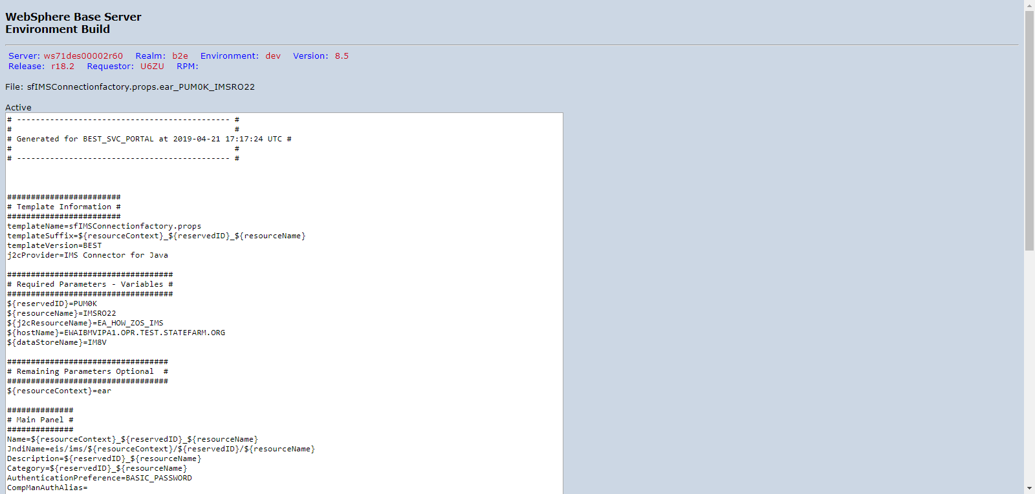

PUM0KD00_DVNTD_sfIMSConnectionfactory.props.ear_PUM0K_IMSRO23.png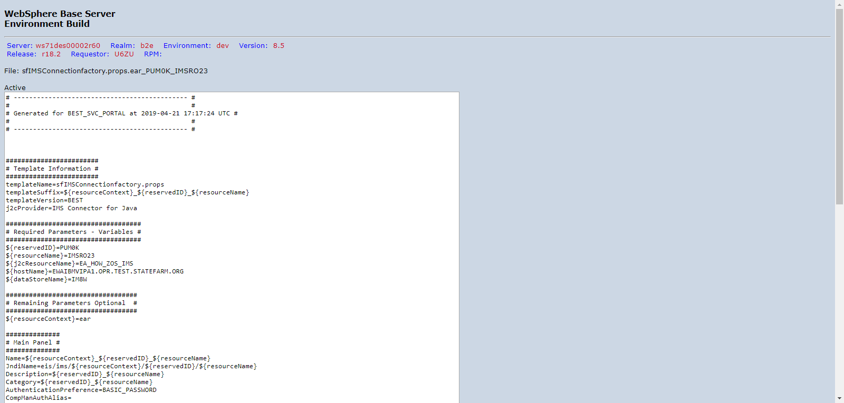

PUM0KD00_DVNTD_sfIMSConnectionfactory.props.ear_PUM0K_IMSRO24.png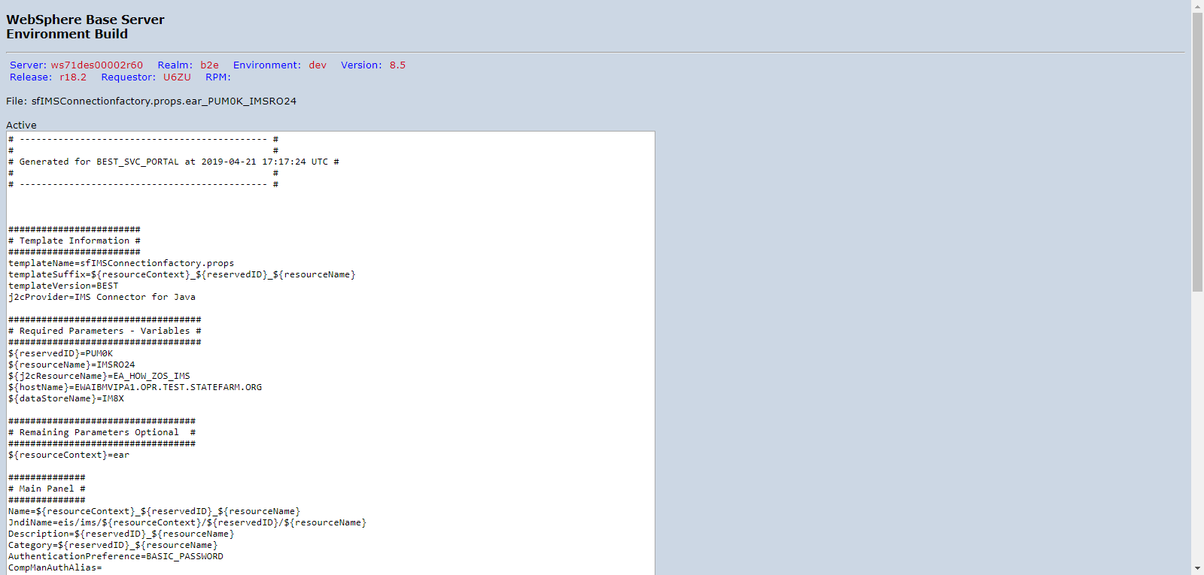

PUM0KD00_DVNTD_sfIMSConnectionfactory.props.ear_PUM0K_IMSRO25.png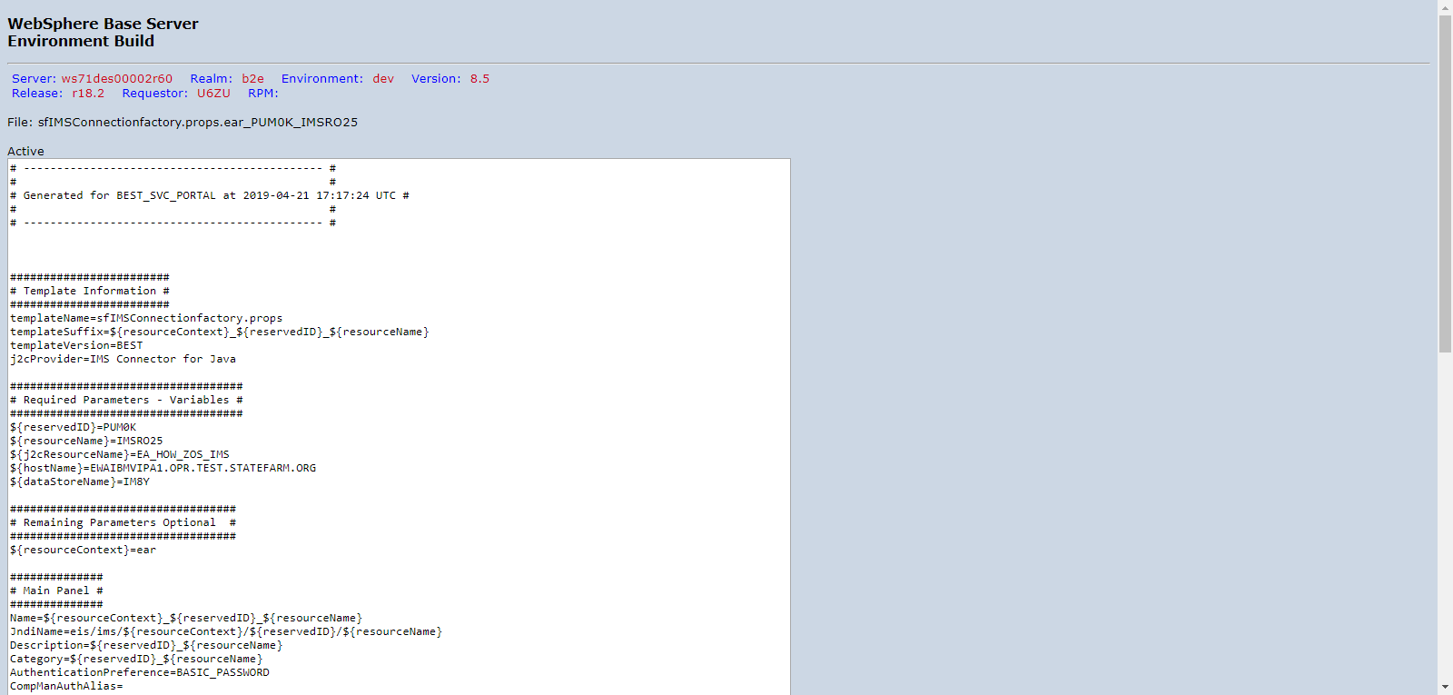

PUM0KD00_DVNTD_sfIMSConnectionfactory.props.ear_PUM0K_IMSRO26.png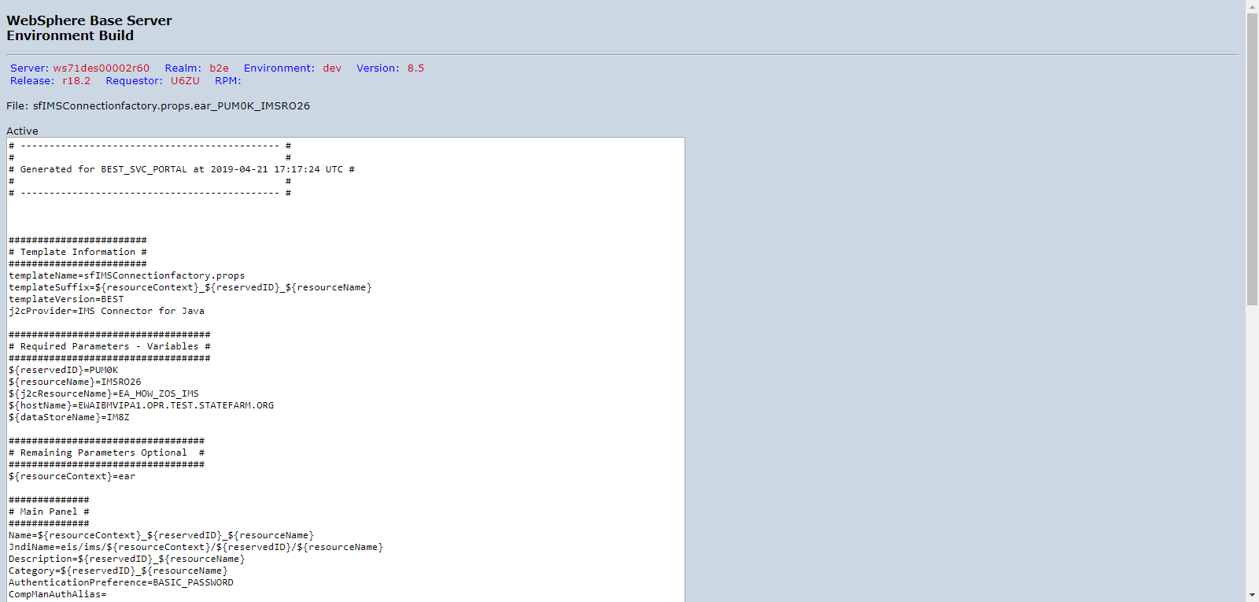

PUM0KD00_DVNTD_sfIMSConnectionfactory.props.ear_PUM0K_IMSRO27.png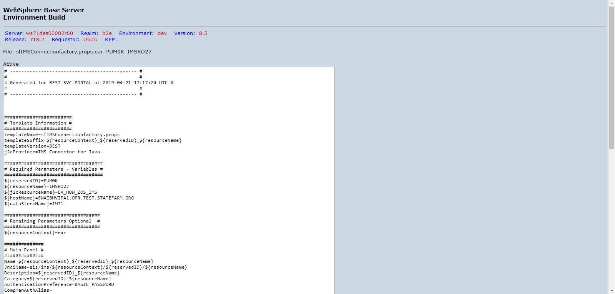

PUM0KD00_DVNTD_sfIMSConnectionfactory.props.ear_PUM0K_IMSRO28.png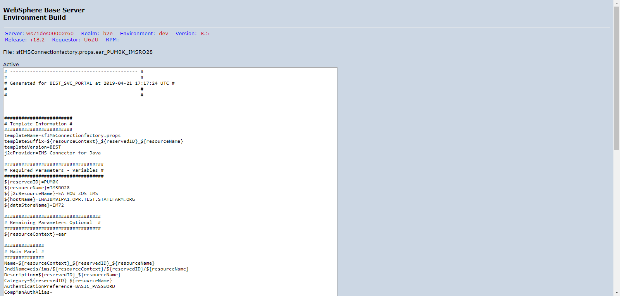

PUM0KD00_DVNTD_sfIMSConnectionfactory.props.ear_PUM0K_IMSRO73.png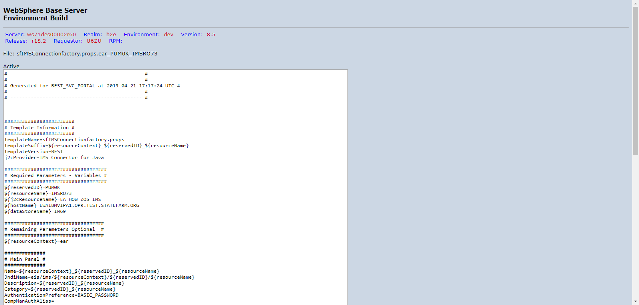

PUM0KD00_DVNTD_sfIMSConnectionfactory.props.ear_PUM0K_IMSRO74.png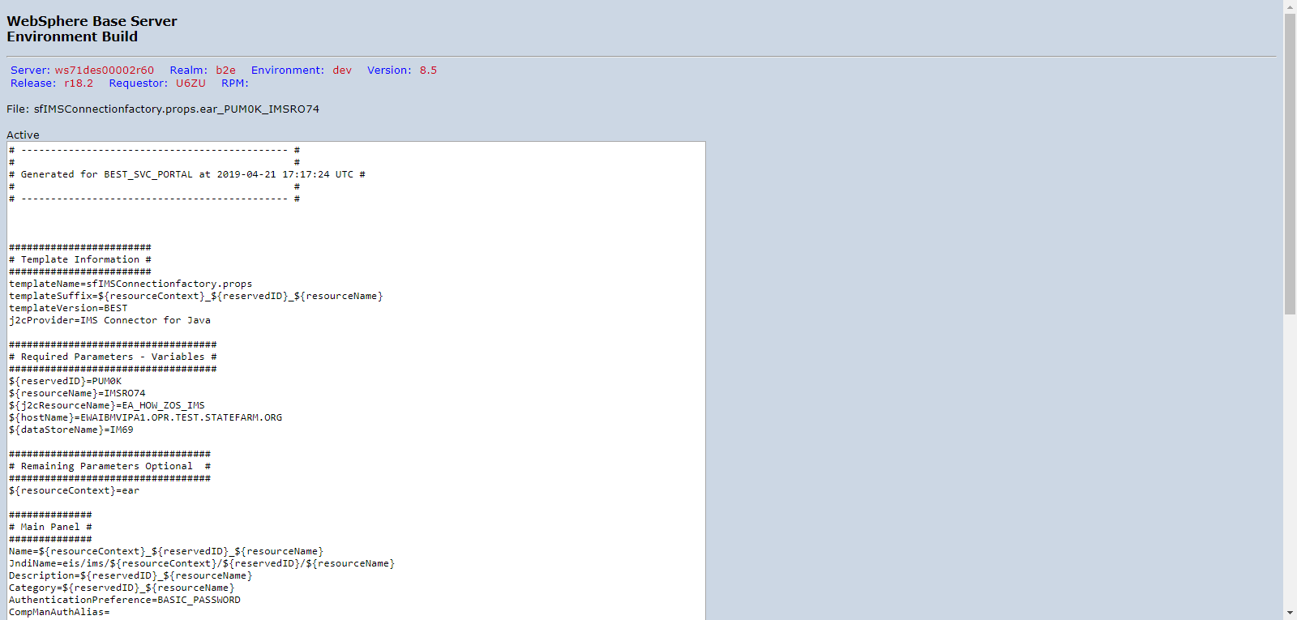

PUM0KD00_DVNTD_sfIMSConnectionfactory.props.ear_PUM0K_IMSRO75.png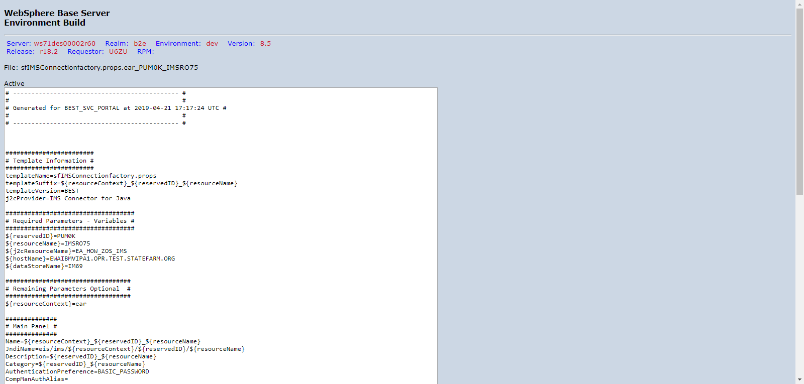

PUM0KD00_DVNTD_sfJ2C.props.ear_PUM0K_AgreementHistoryAuthJ2C.png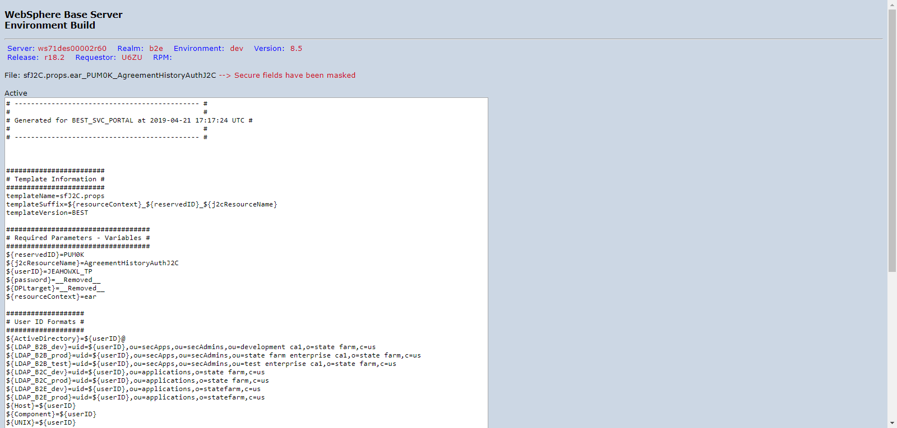

PUM0KD00_DVNTD_sfJ2C.props.ear_PUM0K_EA_HOW_AIX_DB2_METADATA.png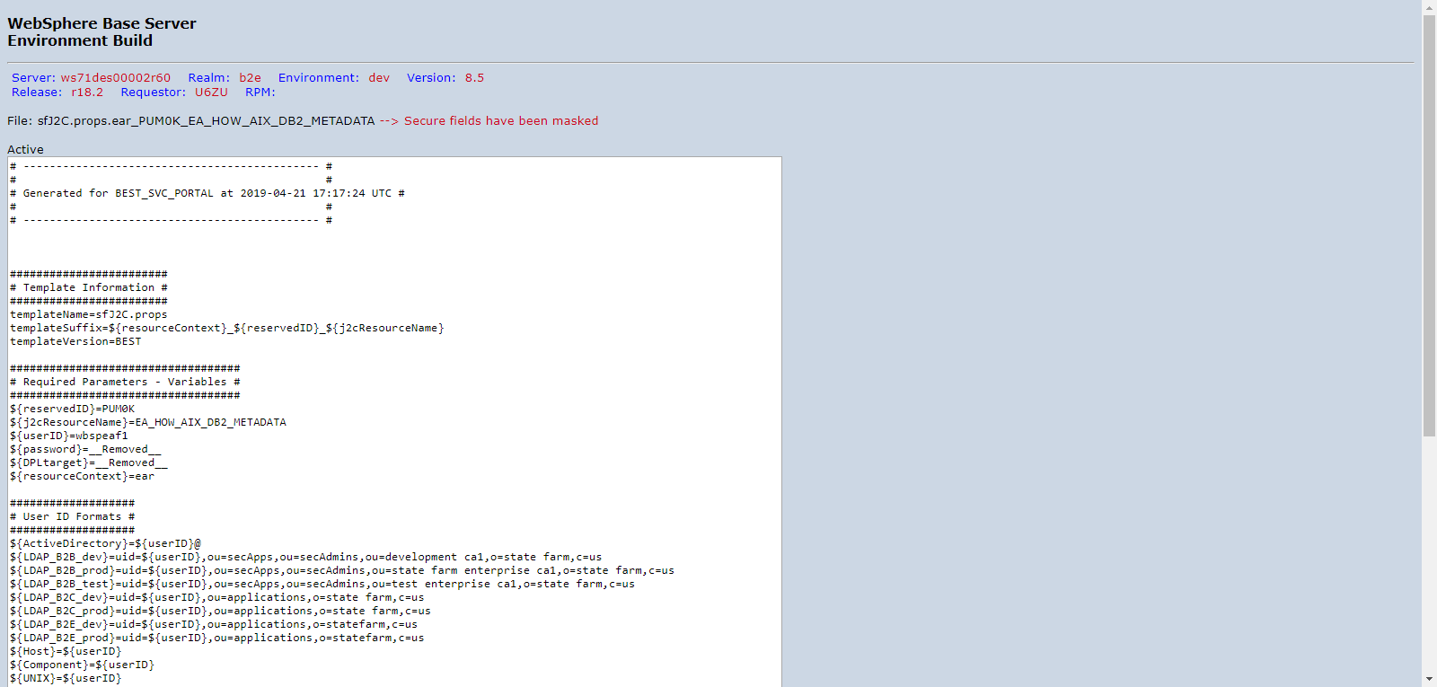

PUM0KD00_DVNTD_sfJ2C.props.ear_PUM0K_EA_HOW_AIX_MQ.png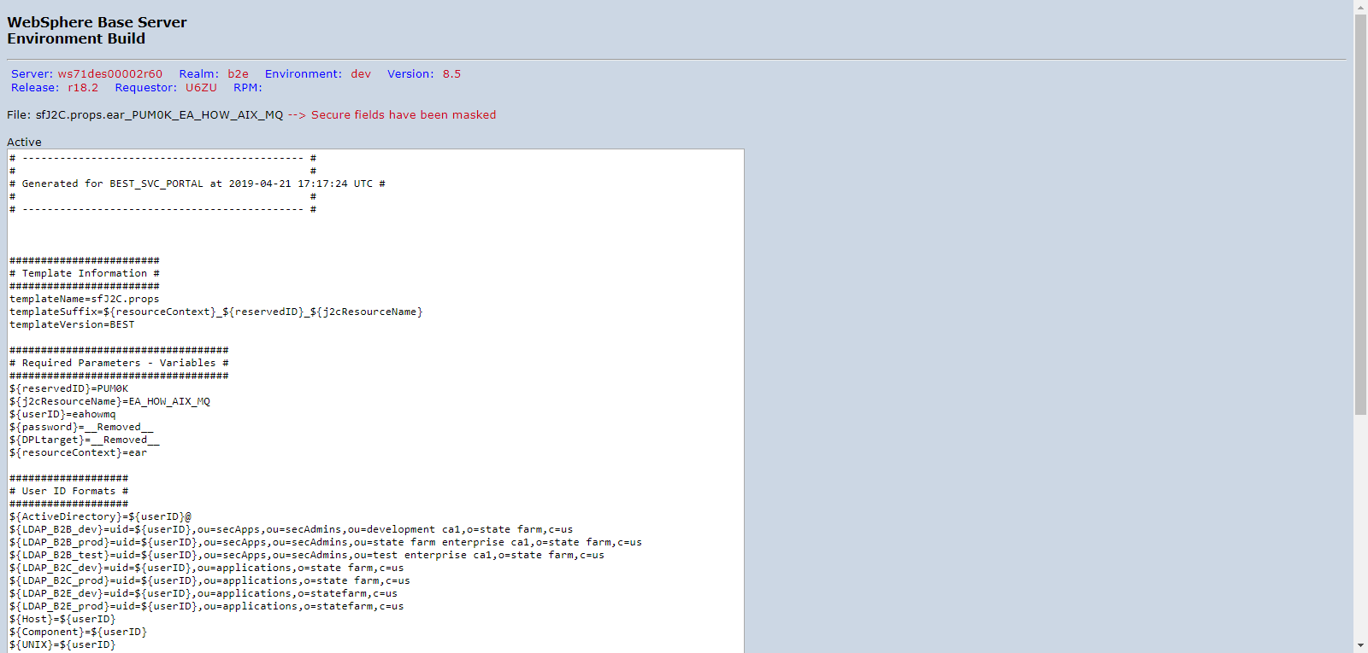

PUM0KD00_DVNTD_sfJ2C.props.ear_PUM0K_EA_HOW_ZOS_DB2_AGTLCR.png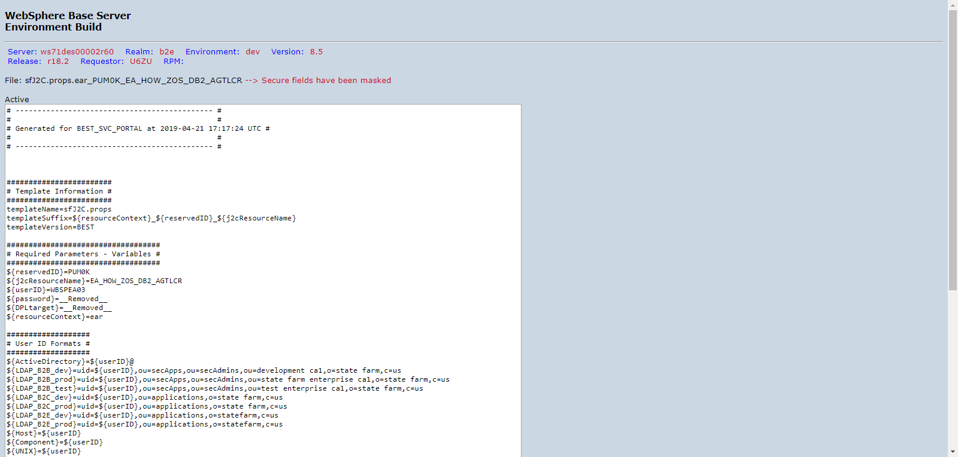

PUM0KD00_DVNTD_sfJ2C.props.ear_PUM0K_EA_HOW_ZOS_DB2_CLTREG.png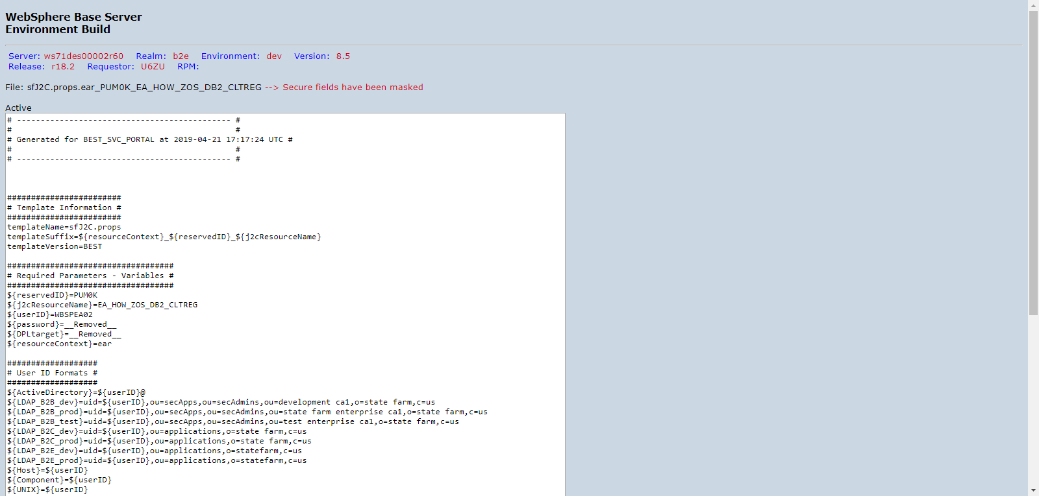

PUM0KD00_DVNTD_sfJ2C.props.ear_PUM0K_EA_HOW_ZOS_IMS.png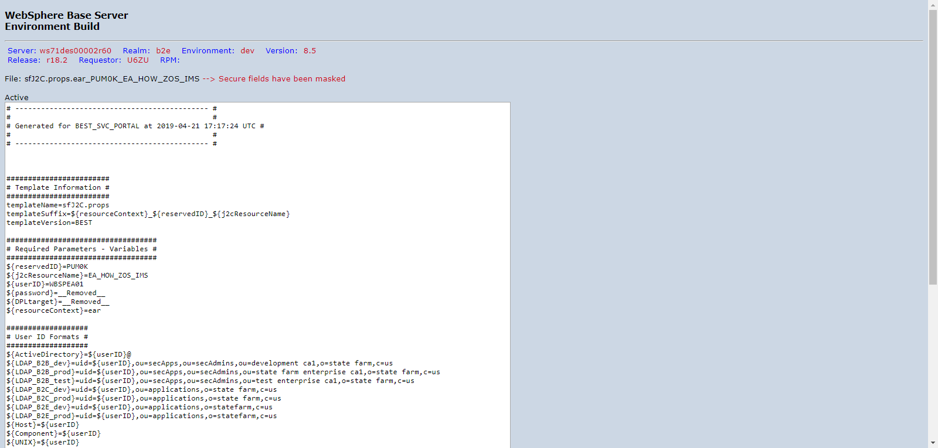

PUM0KD00_DVNTD_sfJ2C.props.ear_PUM0K_EA_HOW_ZOS_MQ.png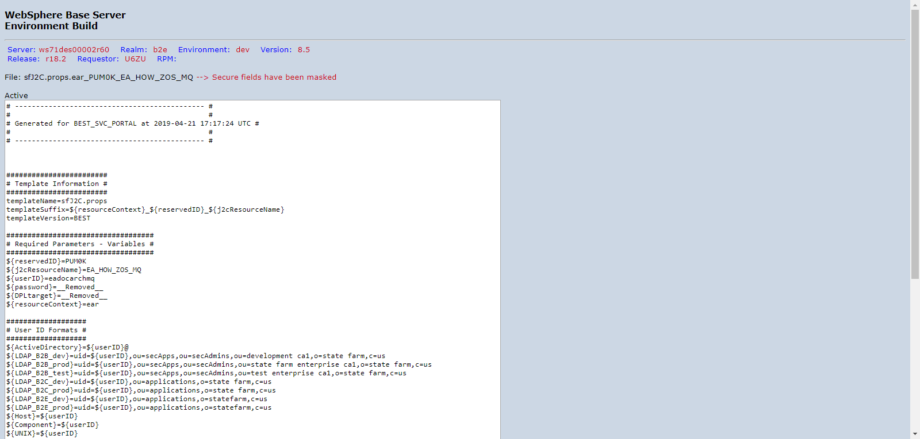

PUM0KD00_DVNTD_sfJ2C.props.ear_PUM0K_MailProviderAuthJ2C.png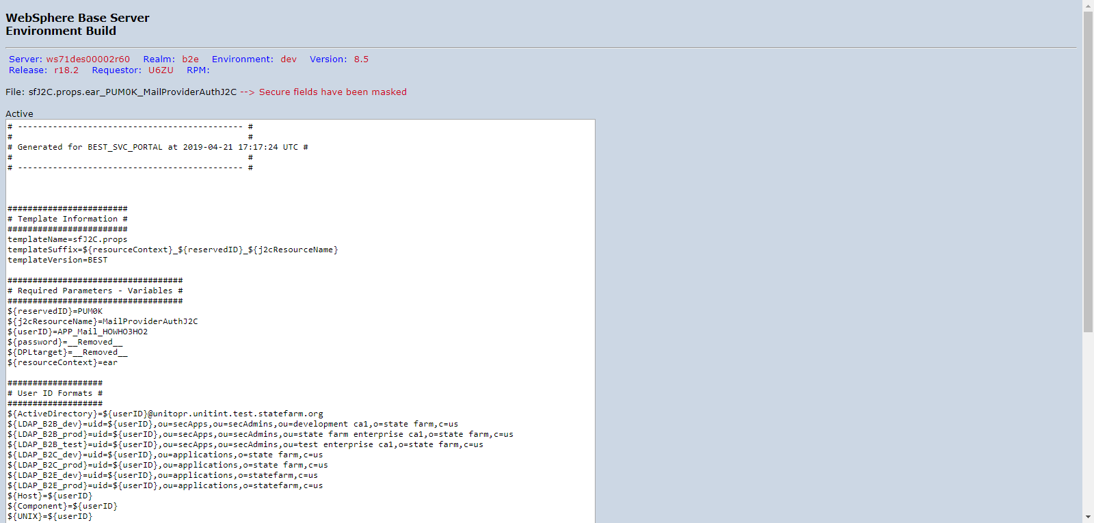

PUM0KD00_DVNTD_sfMQQueueConnectionfactory.props.ear_PUM0K_INSPECTIONQCF_1.png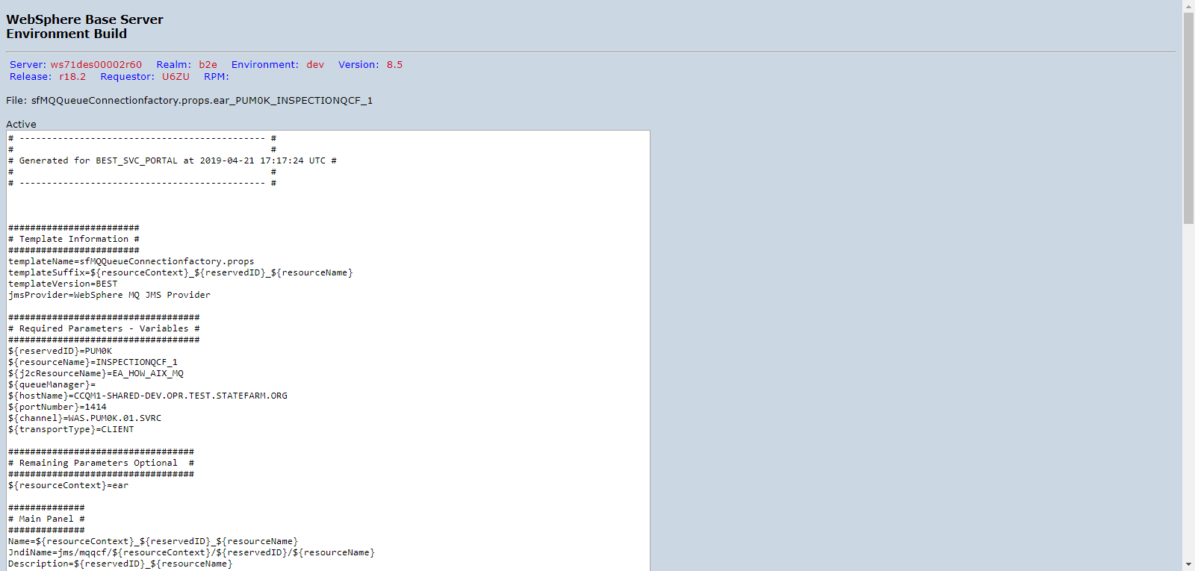

PUM0KD00_DVNTD_sfMQQueueConnectionfactory.props.ear_PUM0K_INSPECTIONQCF_2.png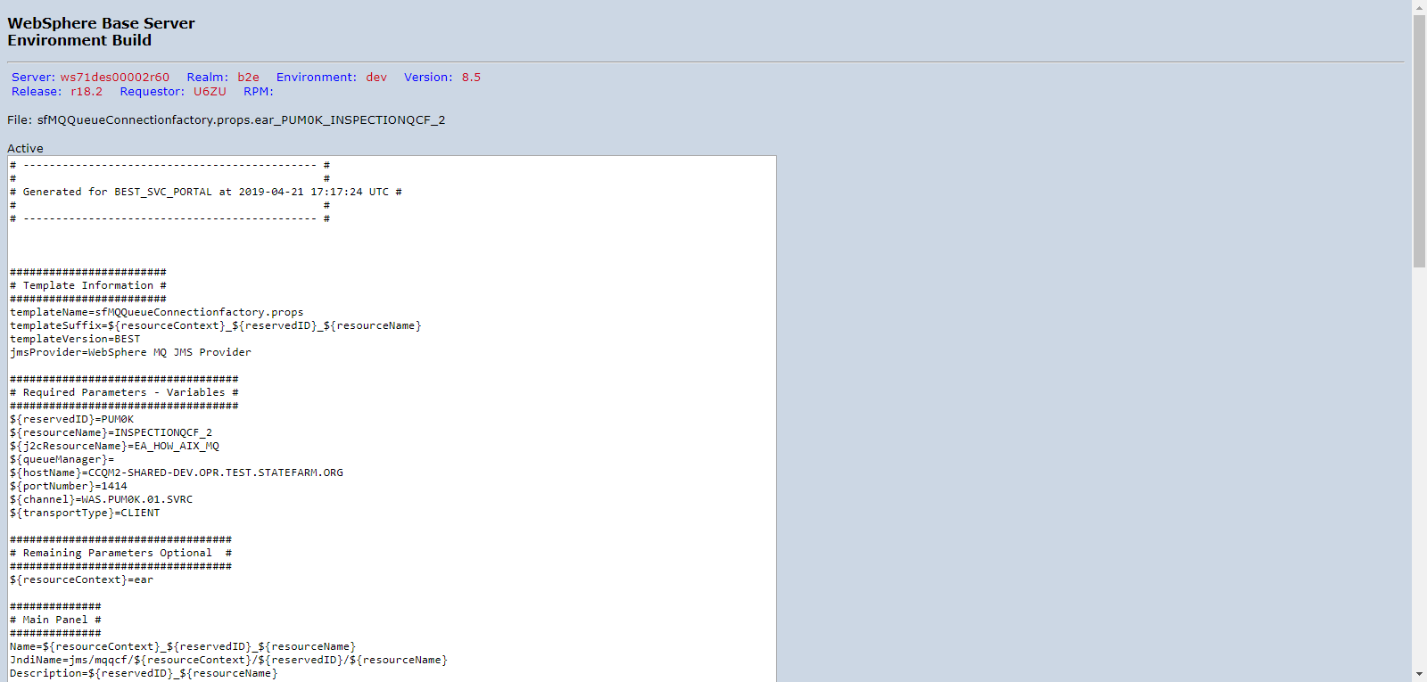

PUM0KD00_DVNTD_sfMQQueueConnectionfactory.props.ear_PUM0K_MQ_CONNECTION_FACTORY_1.png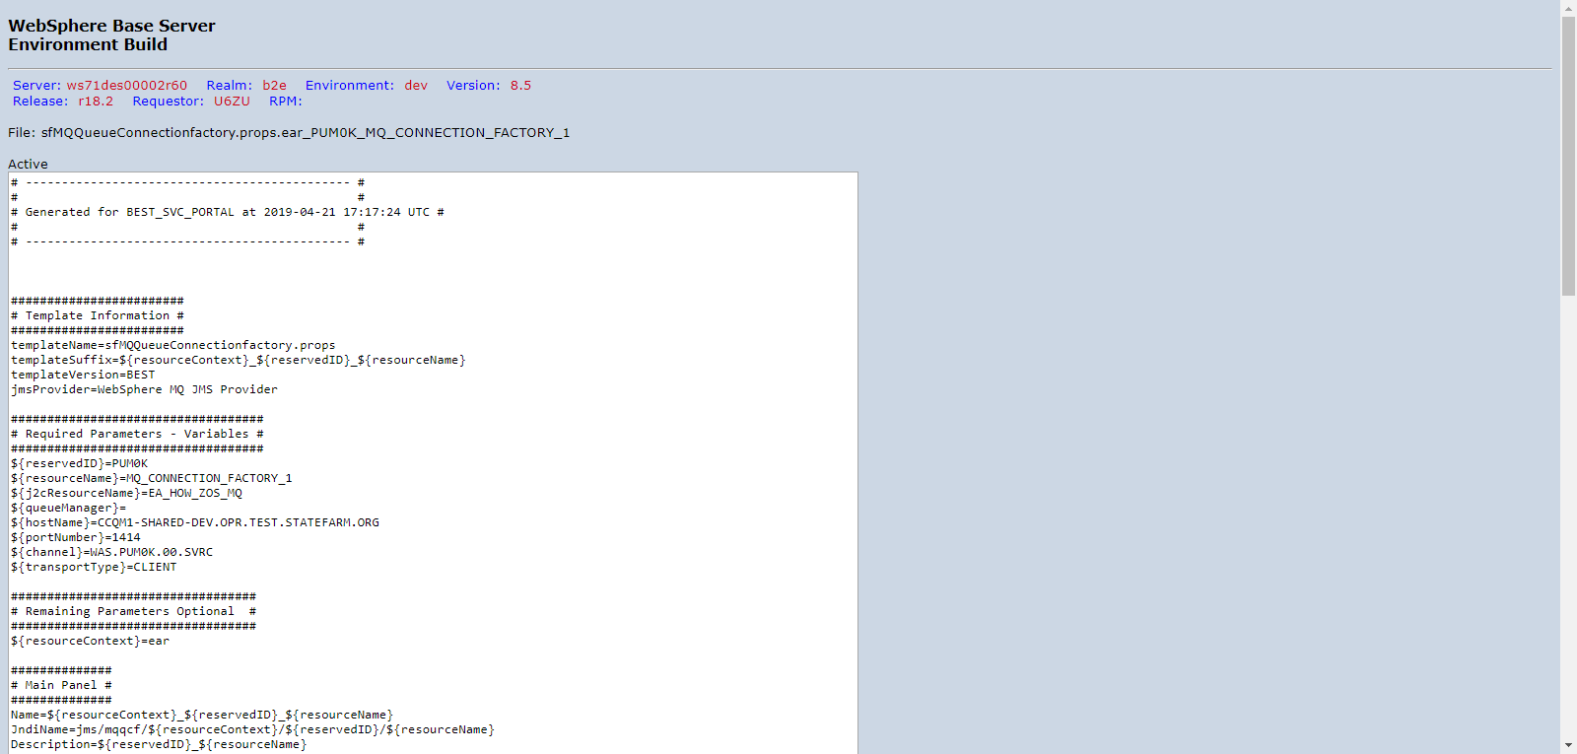

PUM0KD00_DVNTD_sfMQQueueConnectionfactory.props.ear_PUM0K_MQ_CONNECTION_FACTORY_2.png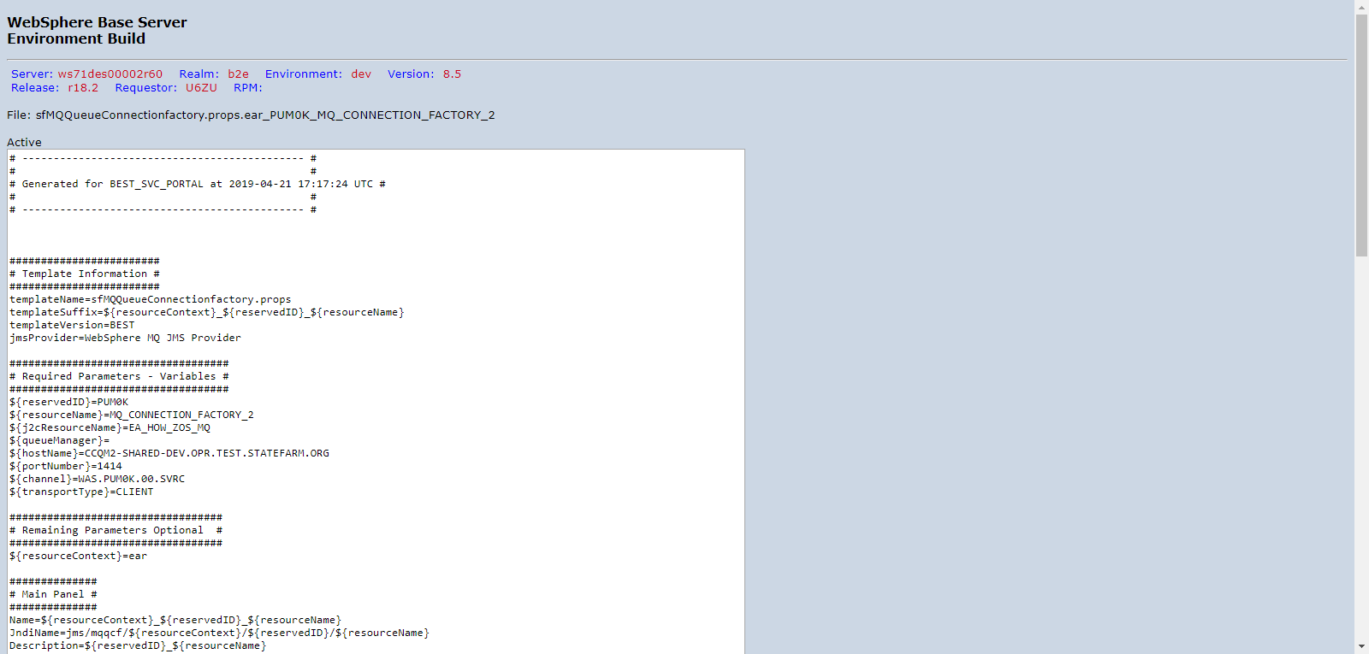

PUM0KD00_DVNTD_sfMQQueueDestination.props.ear_PUM0K_A0630_EA_DOCARCHIVAL_IN.png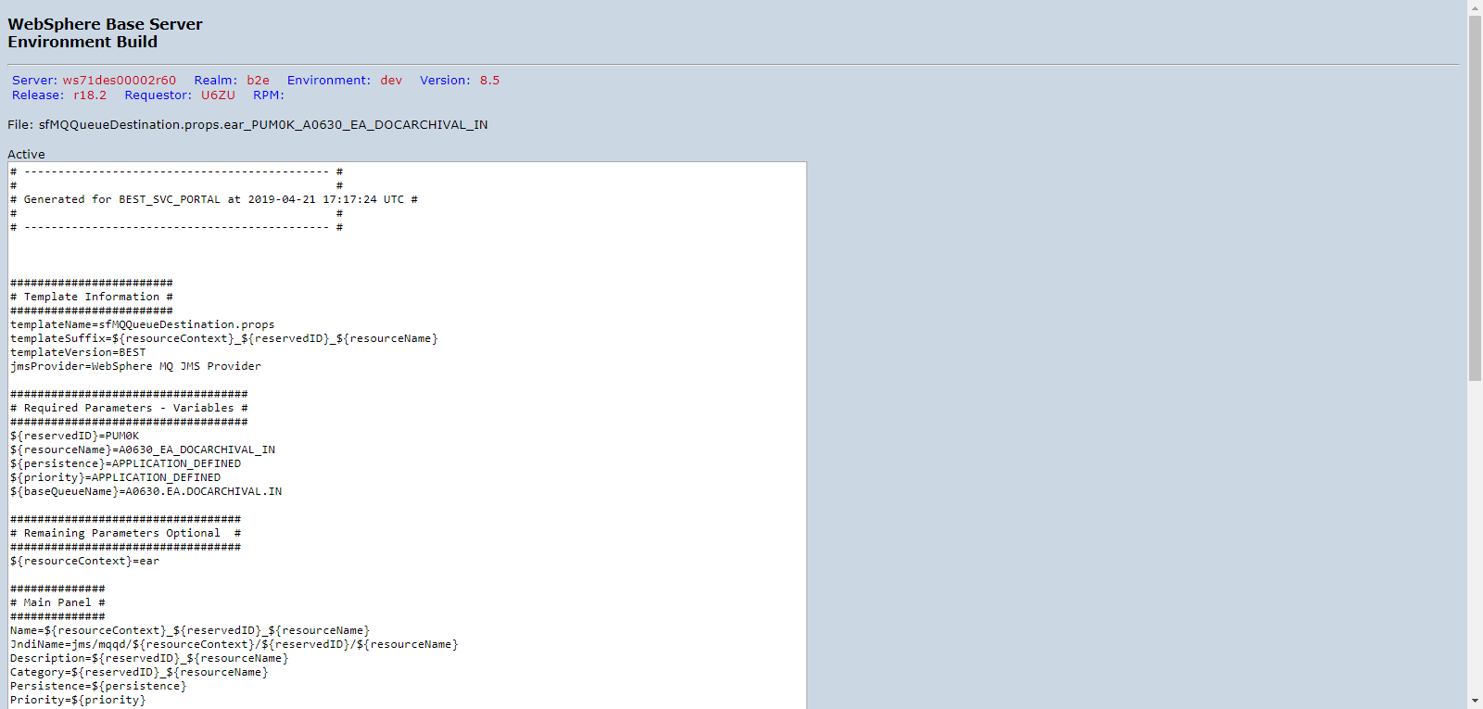

PUM0KD00_DVNTD_sfMQQueueDestination.props.ear_PUM0K_A1179_PUT_FIREEA_INSPECTION.png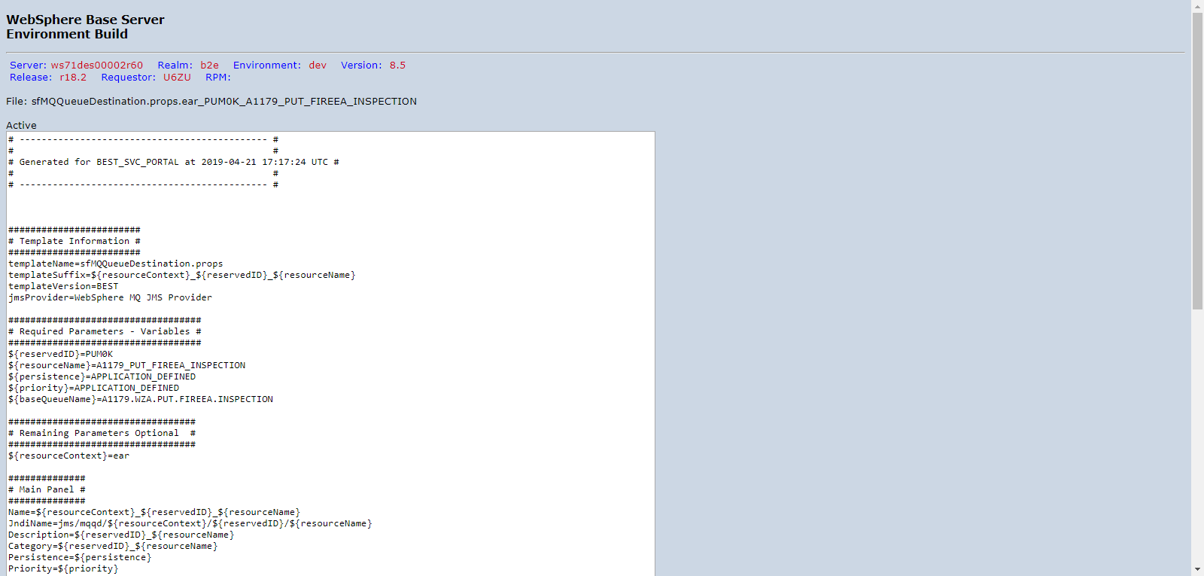

PUM0KD00_DVNTD_sfappserver.props.server1.png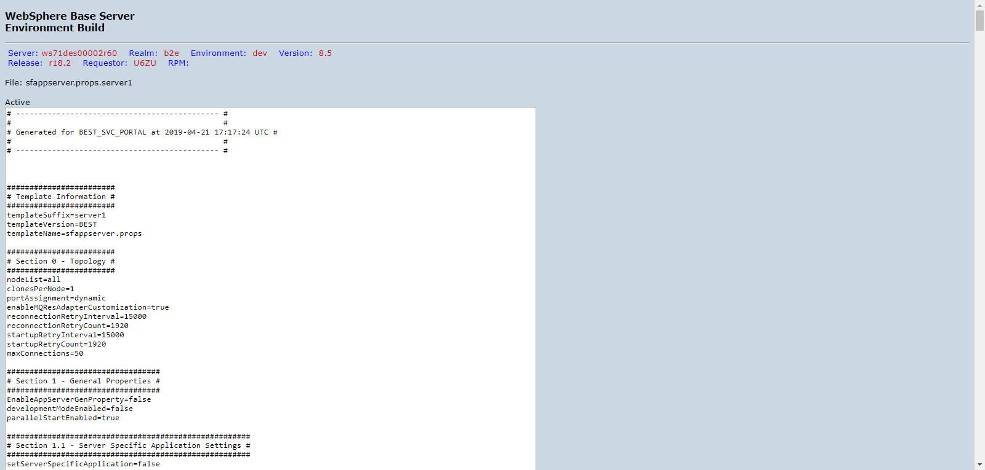

PUM0KD00_DVNTD_sfurl.props.ear_PUM0K_ImageManagerContentBase.png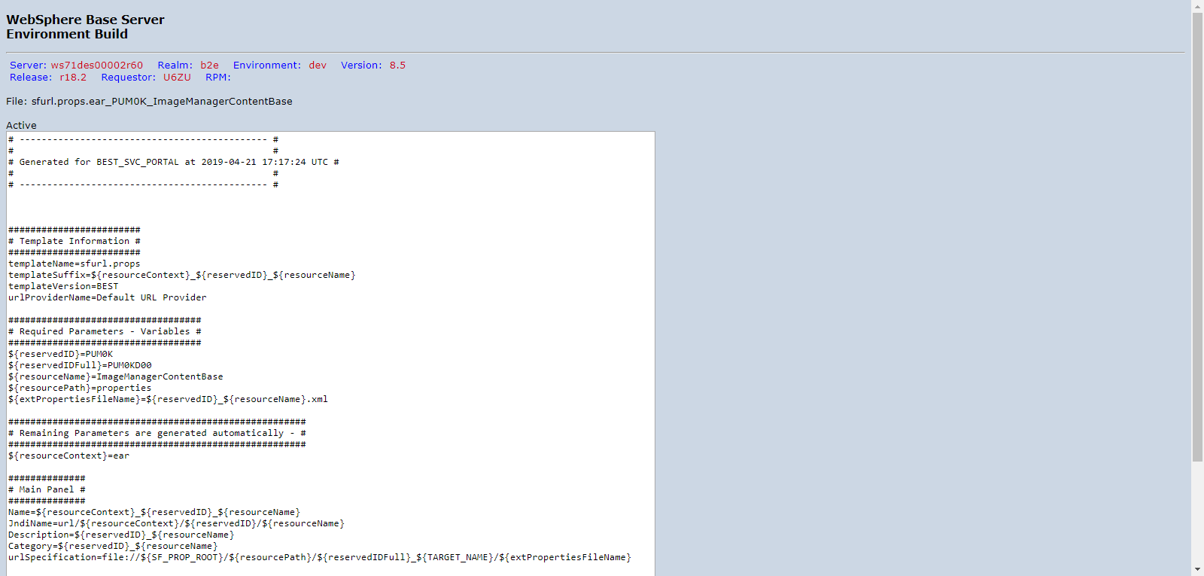

PUM0KD00_DVNTD_sfurl.props.ear_PUM0K_PUM0K_App.png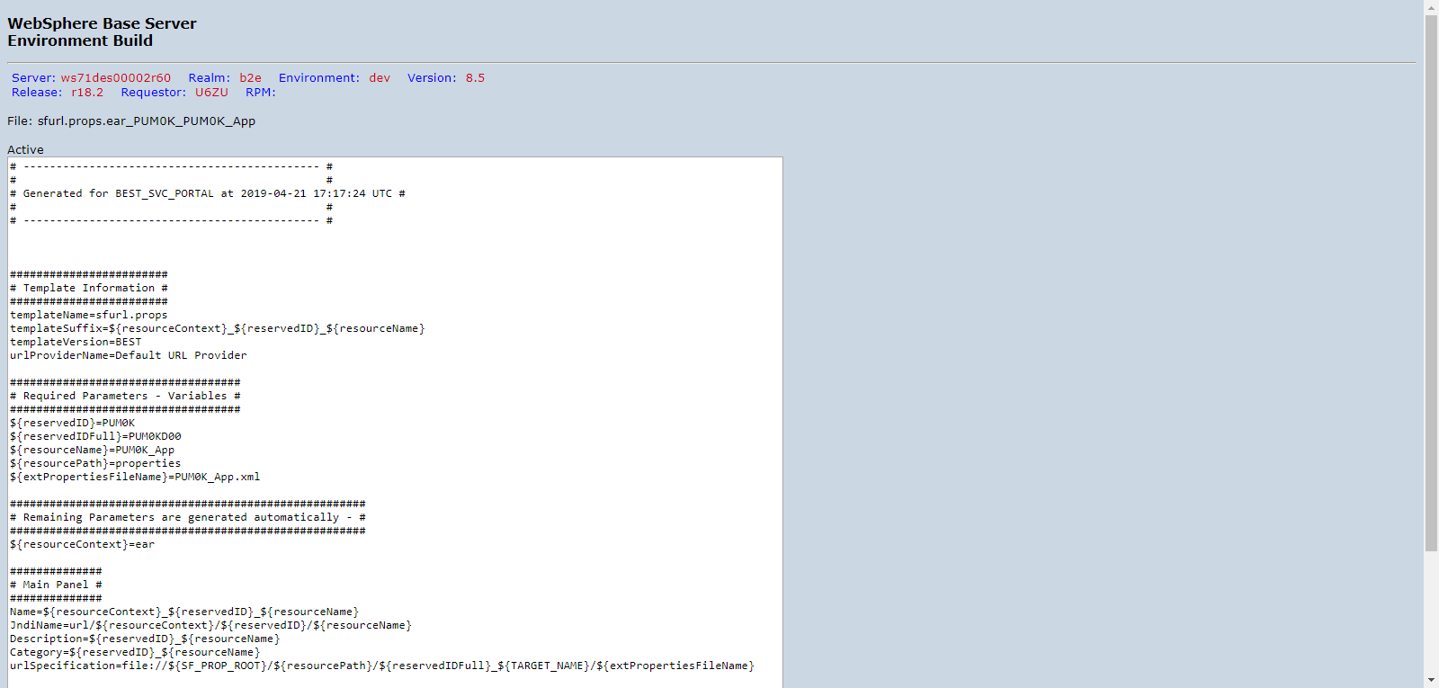

PUM0KD00_DVNTD_sfurl.props.ear_PUM0K_PUM0K_Controller.png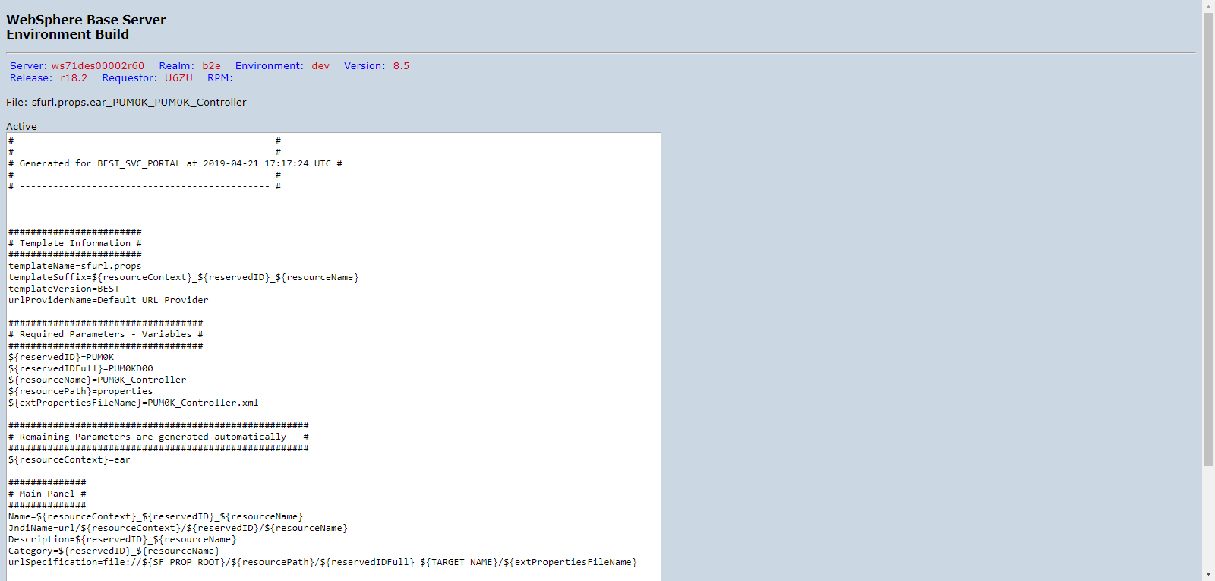

PUM0KD00_DVNTD_roleToUser.png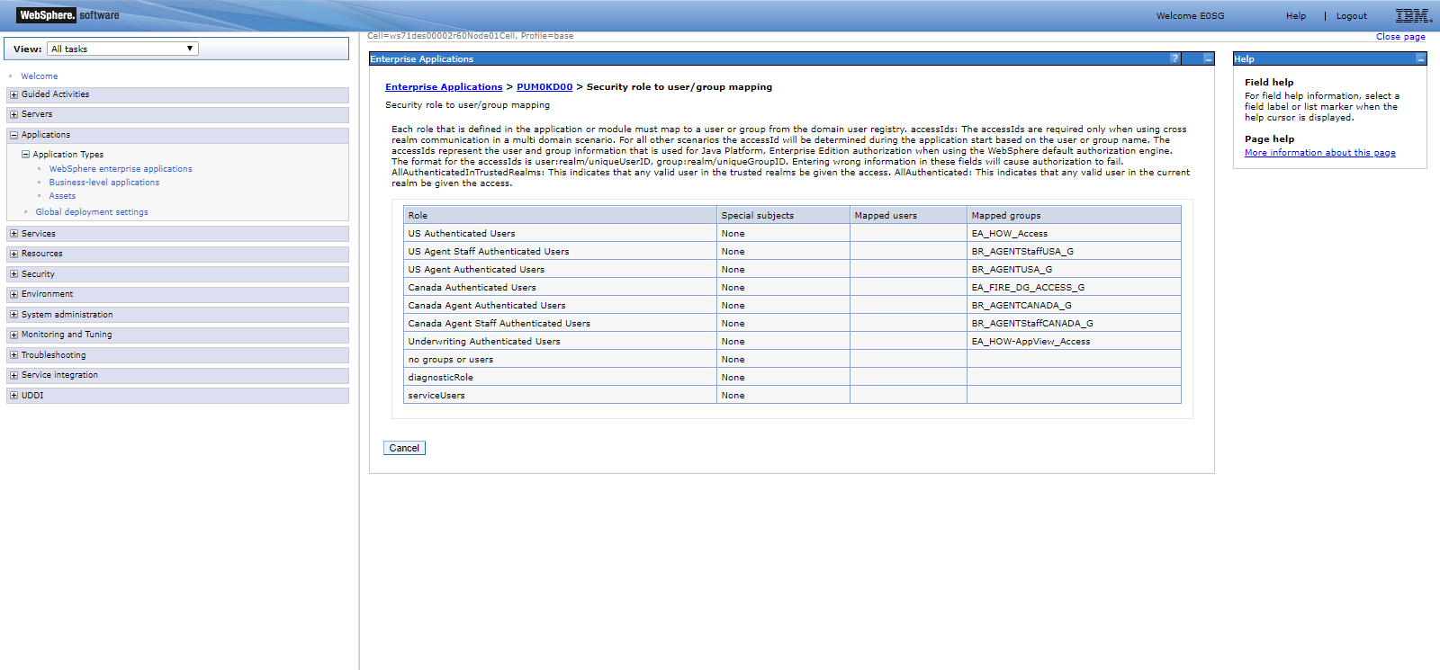

PUM0KD00_DVNTD_webservices.png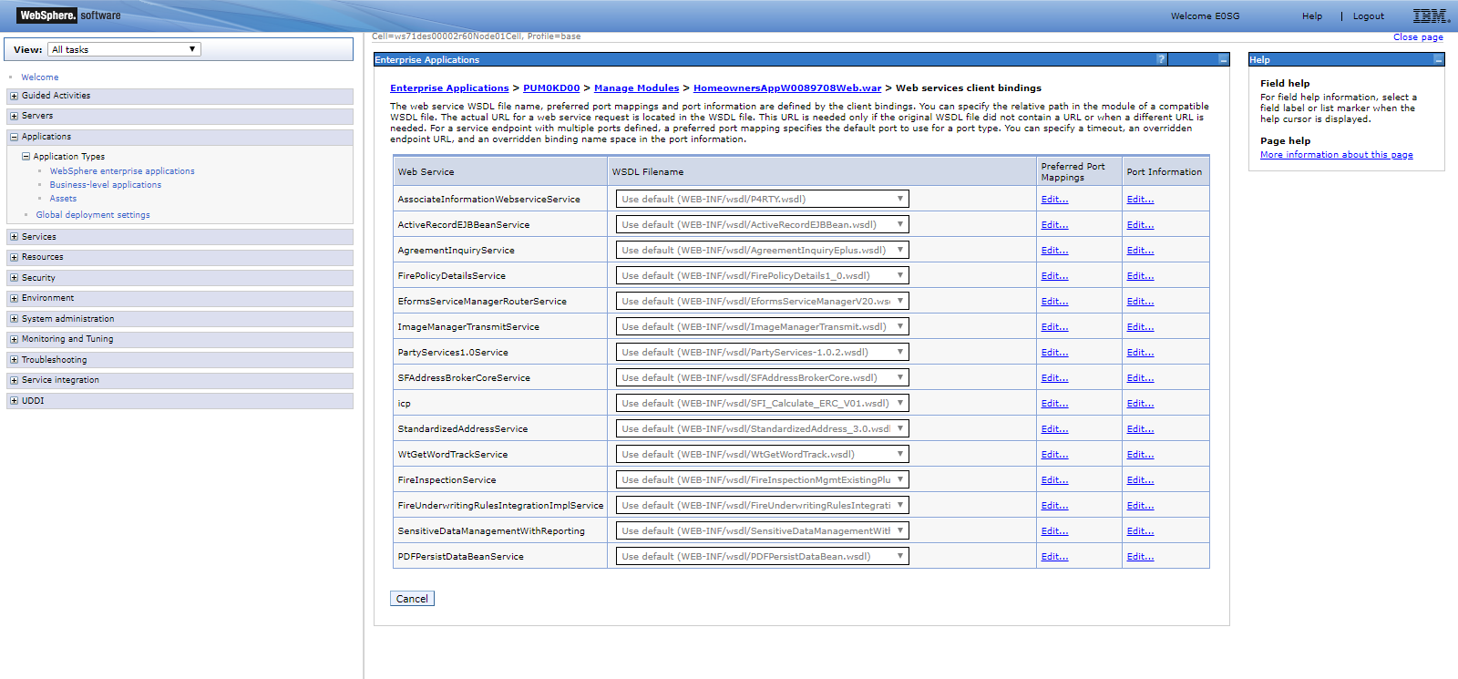

https://sfesb-dev.opr.test.statefarm.org/B2E/associateInformation/services/1.0/AssociateInformationWebservice/DVNTD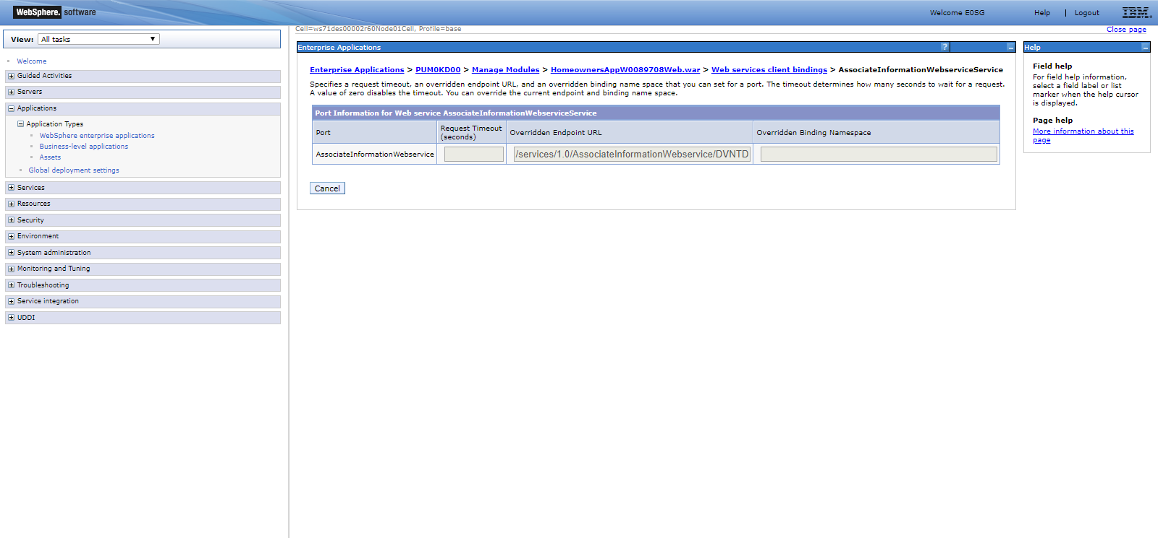

https://sfesb-dev.opr.test.statefarm.org/B2E/ActRecService/services/ActiveRecordEJBean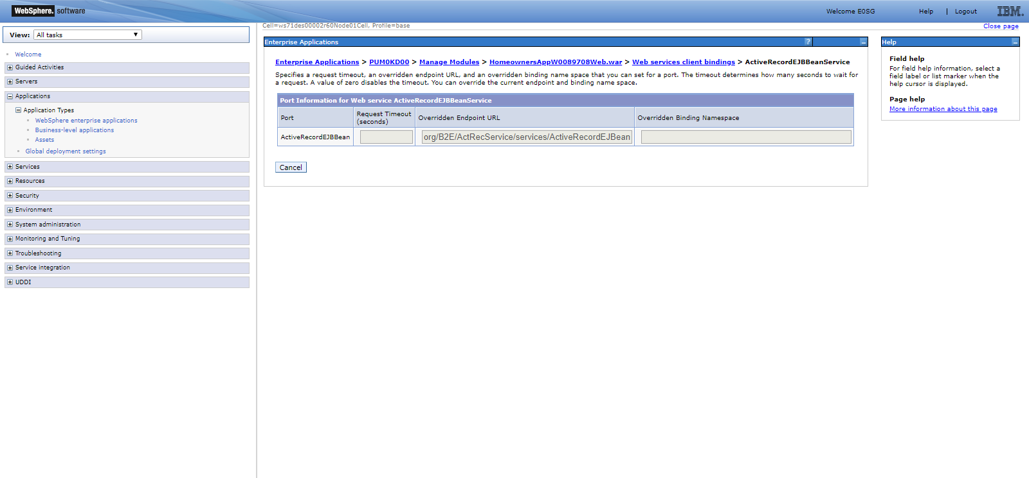

https://sfesb-dev.opr.test.statefarm.org/B2E/agreementinquiry_eplus/services/AgreementInquiry_NPI/dvntd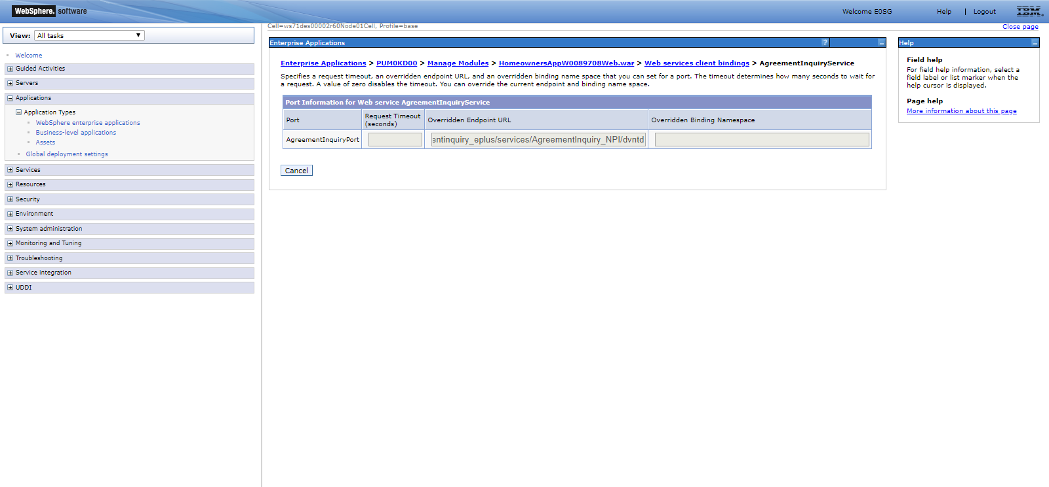

https://sfesb-dev.opr.test.statefarm.org/B2E/firepolicydetails_v1/services/FirePolicyDetails1.0/TSSWZA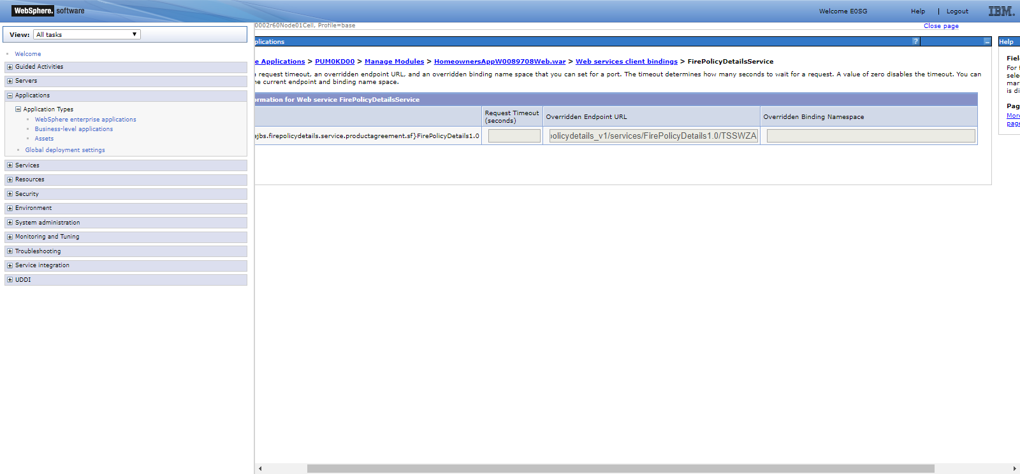

https://sfesb-dev.opr.test.statefarm.org/B2E/eformsservices_v2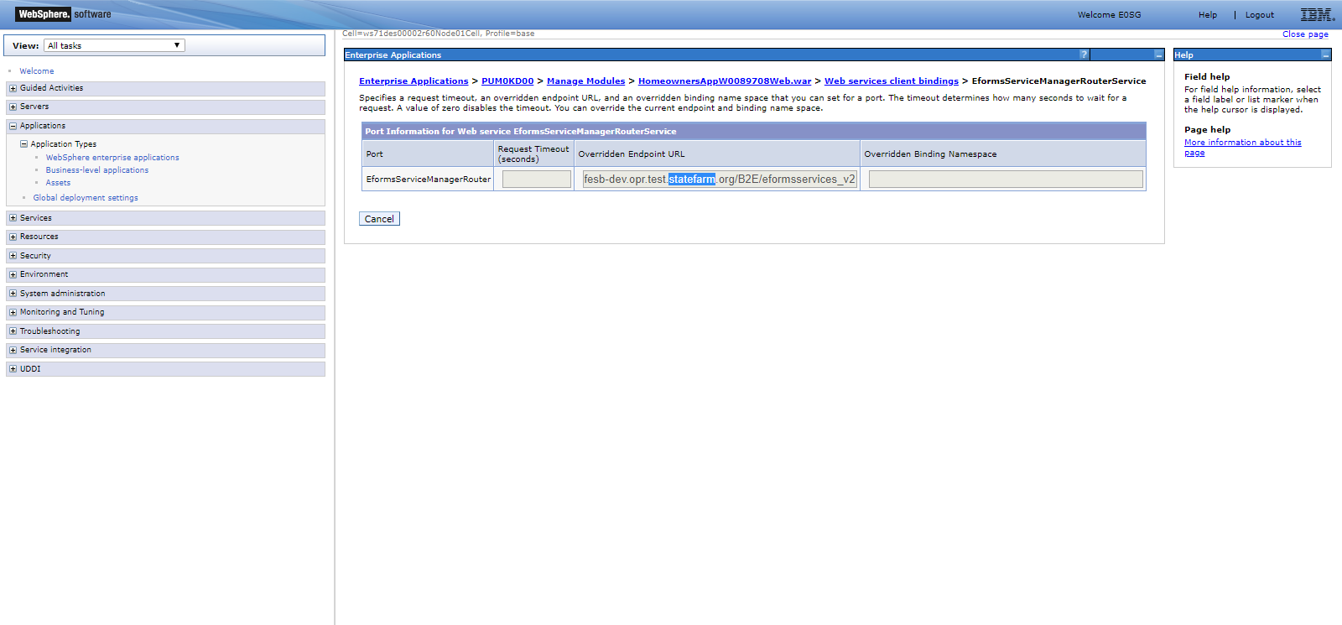

https://sfesb-dev.opr.test.statefarm.org/B2E/IM_TRANSMIT-EJBHttpRouter/services/ImageManagerTransmit/SERV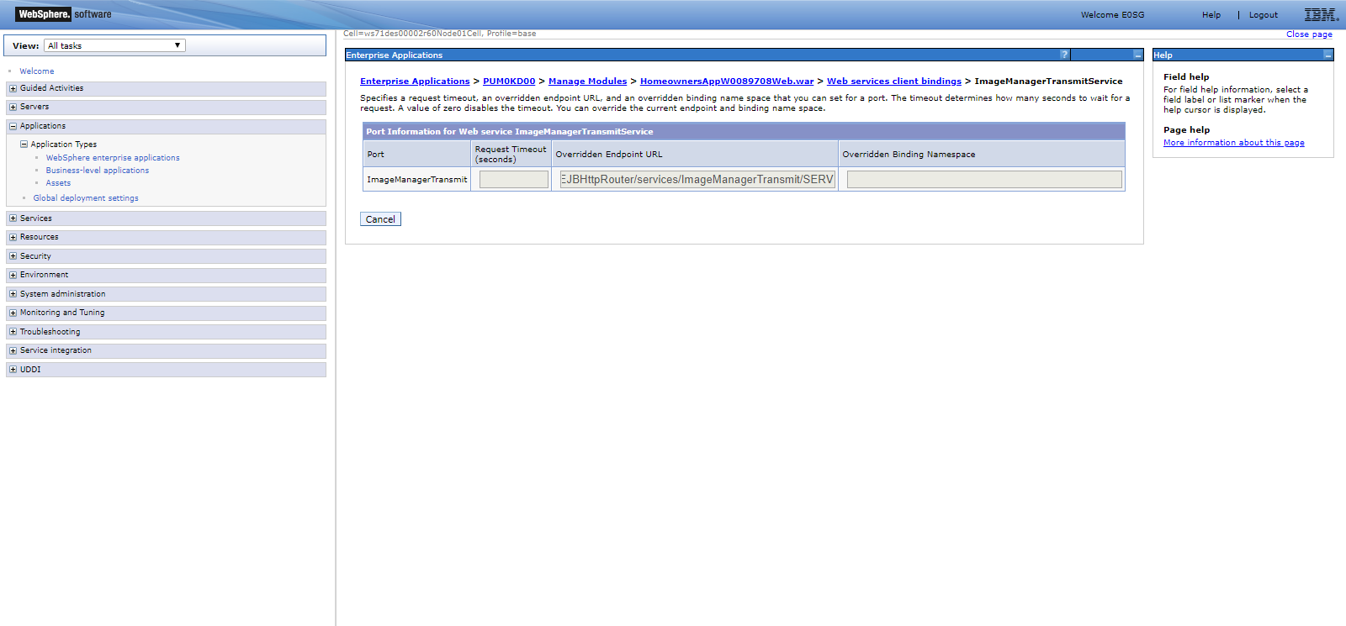

https://sfesb-dev.opr.test.statefarm.org/B2E/PartyServices_v2/services/PartyServices1.0/SERV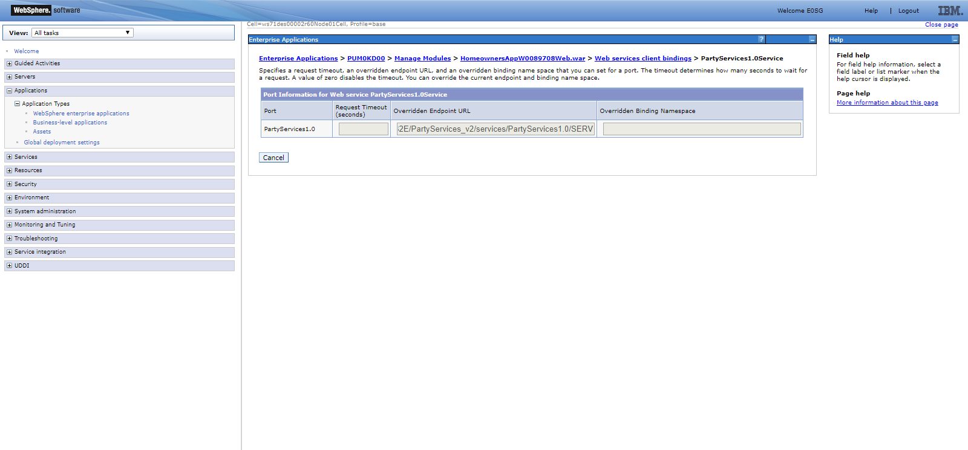

https://sfesb-dev.opr.test.statefarm.org/B2E/sfabgissrvcdmti/services/SFAddressBrokerCore/Dev2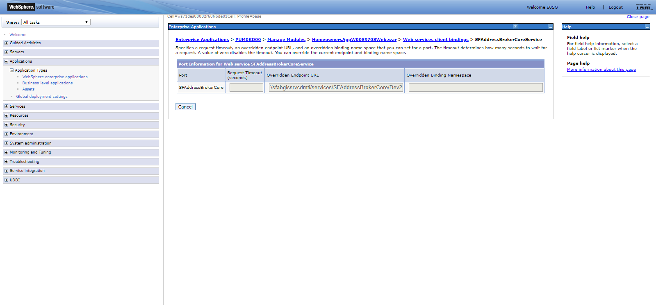

https://sfmbdev.opr.test.statefarm.org:7043/IBUS/V02/SFI/Calculate/ERC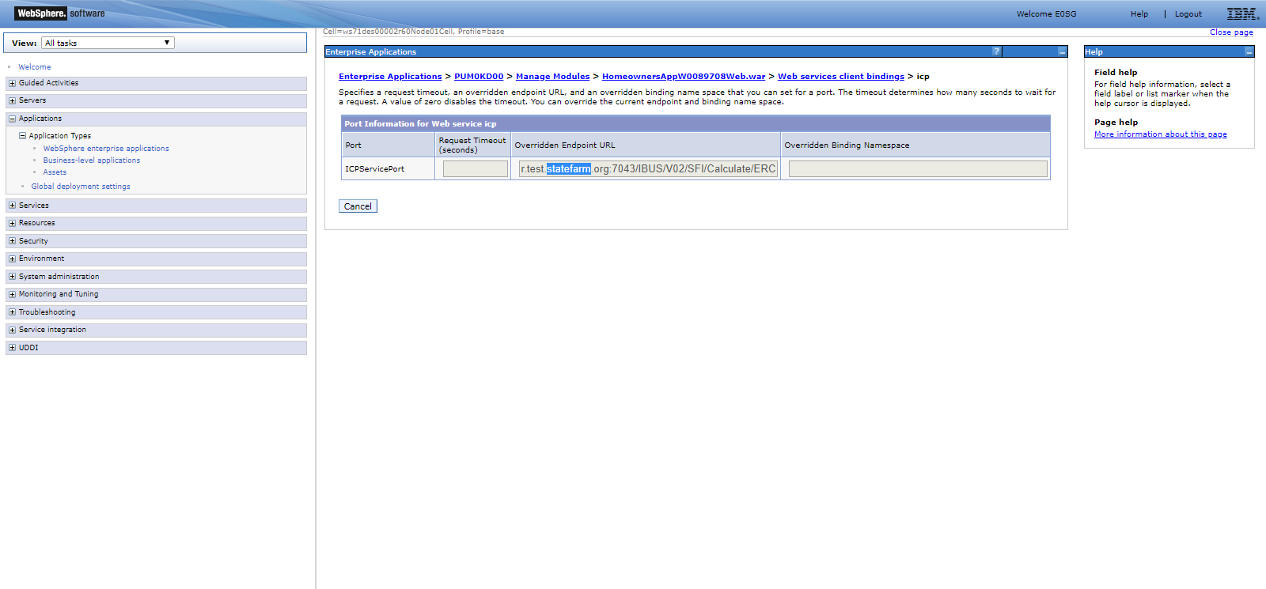

https://sfesb-dev.opr.test.statefarm.org/B2E/AddressStd3.0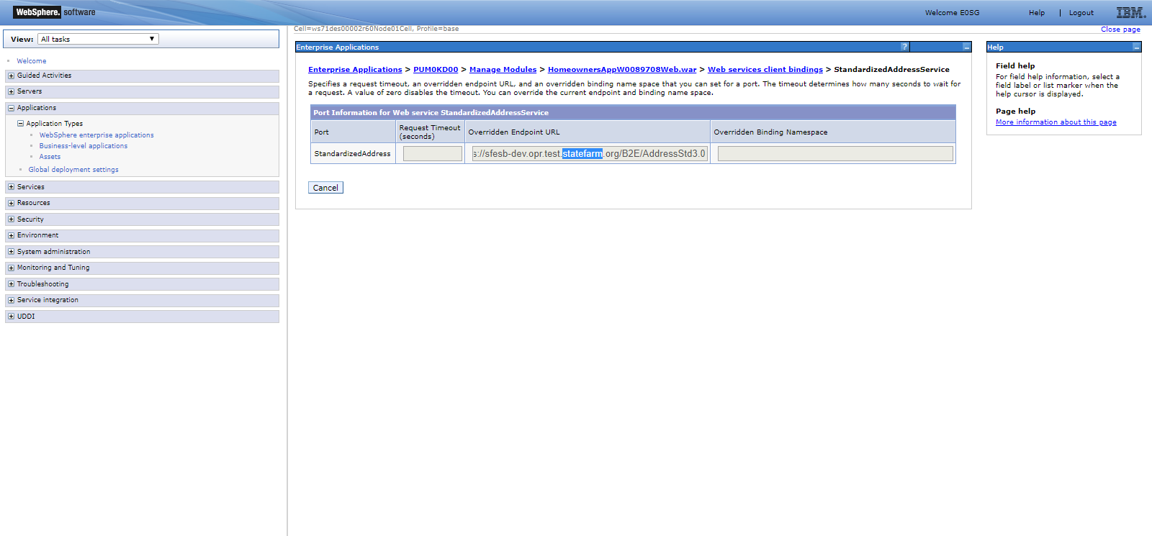

https://sfesb-dev.opr.test.statefarm.org/B2E/wordtracks/shared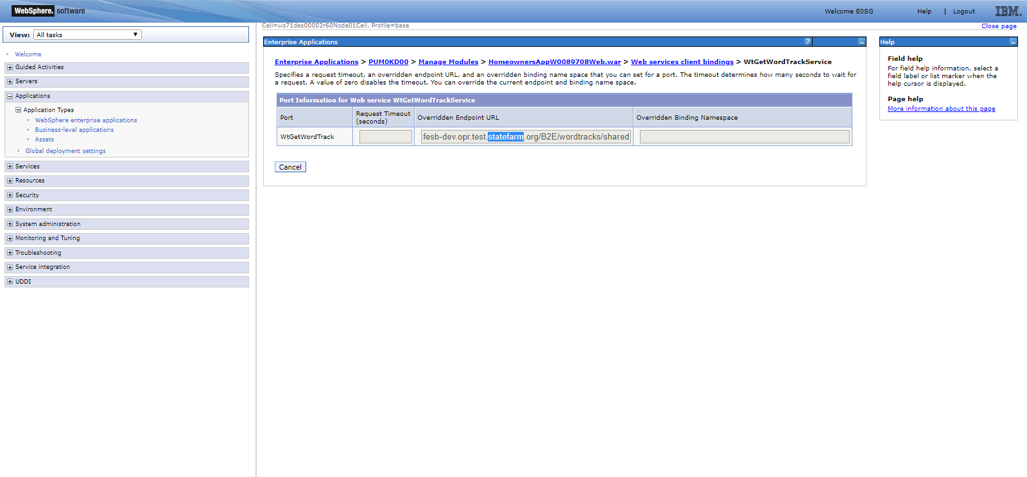

https://sfesb-dev.opr.test.statefarm.org/B2E/fireinspectionmgmt_v4/services/FireInspectionMgmt/SERV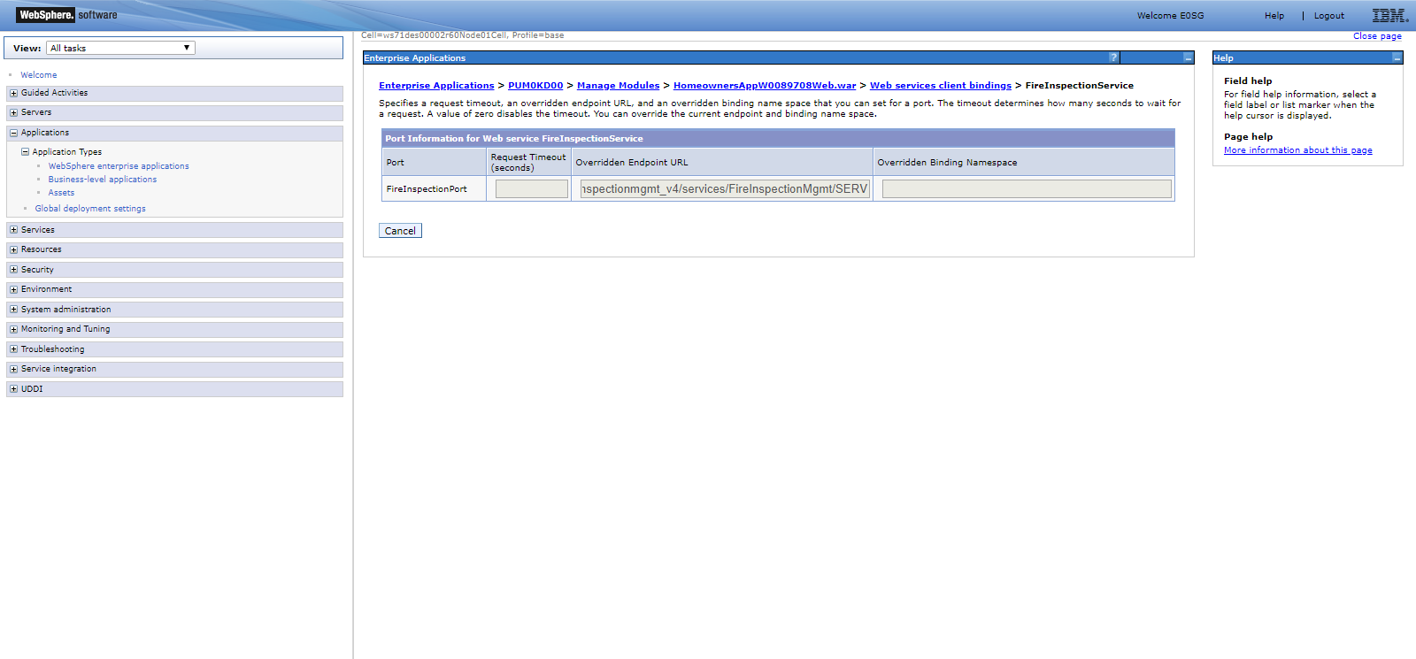

https://sfesb-dev.opr.test.statefarm.org/B2E/FireUnderwritingRulesIntegration-svc/FireUnderwritingRulesIntegration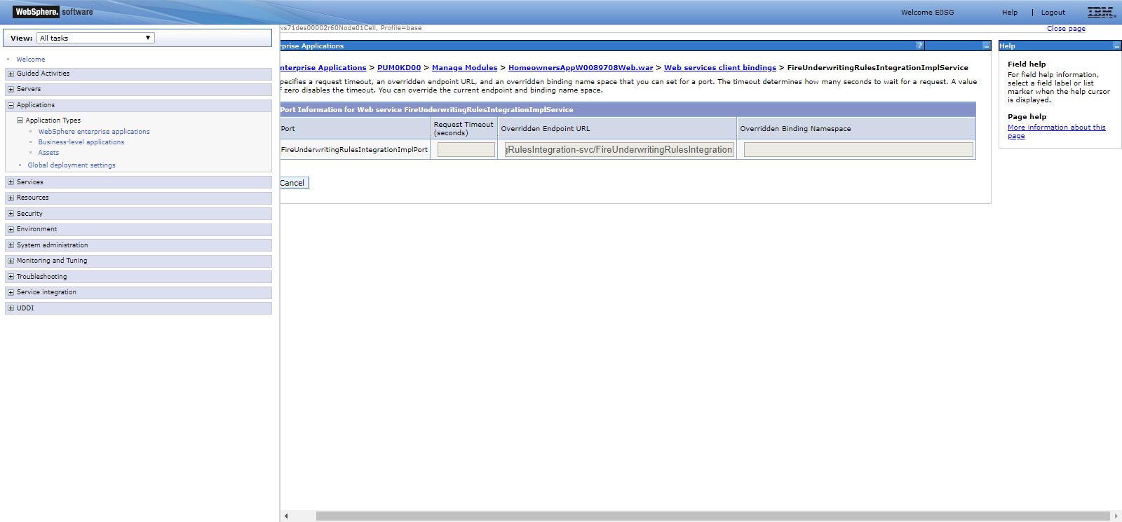

https://sfesb-sys.opr.test.statefarm.org/ICP/HOW/SensitiveDataManagementWithReporting/SERV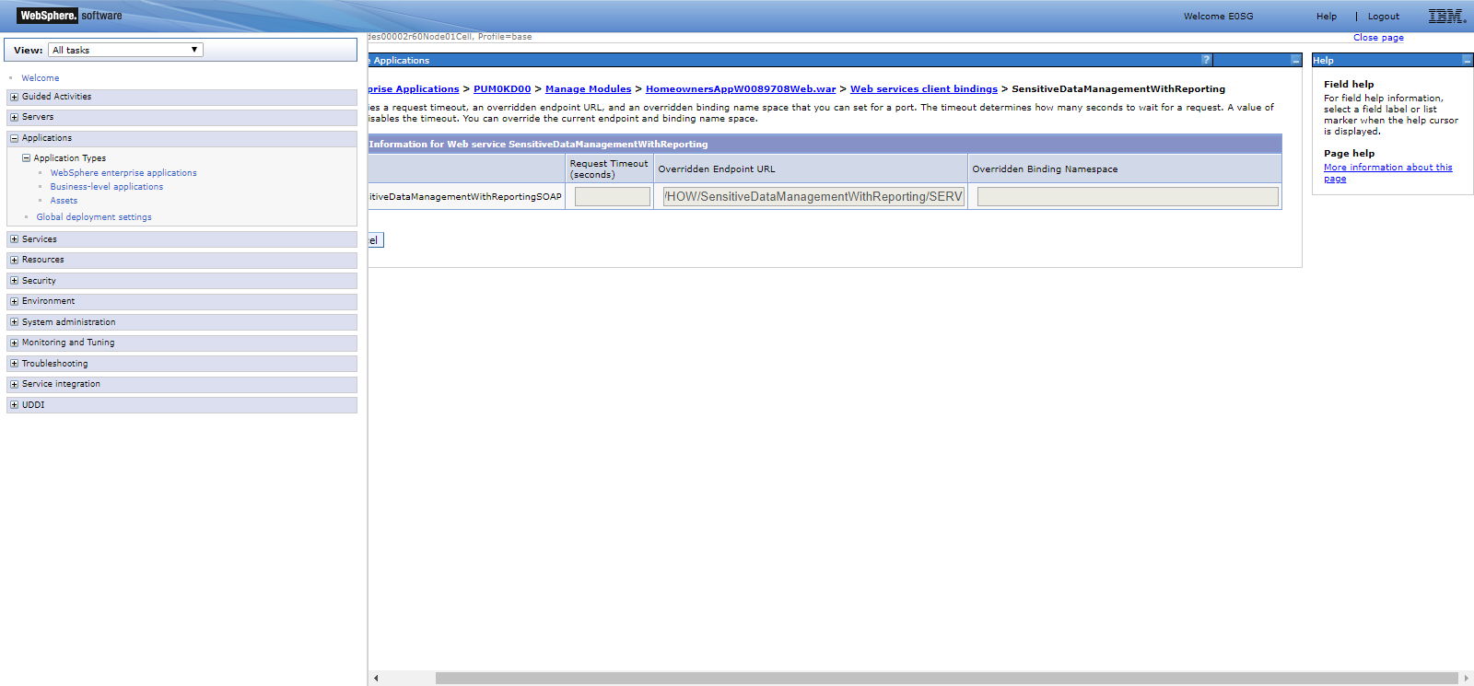

https://sfesb-dev.opr.test.statefarm.org/B2E/pdfpersistdata_v4/services/PDFPersistDataBean/SERV